

**SCHOOL OF INFOCOMM TECHNOLOGY**

Diploma in CyberSecurity & Forensics

**Front End Development (FED)**

**ASSIGNMENT**

Duration: **Week 12 to Week 15 (4 Jan – 31 Jan 2021)**

Weightage: **40%**

Individual/Team/Both: **Both**

Deadline: **2359hr Friday 31 Jan 2021**

|  |  |  |  |
| --- | --- | --- | --- |
| Class Group | P03 | Team Number |  |
| Tutor | Mohamed Saifulamri OMAR | | |
| Project Theme | Fight Against Dengue | | |
| Team members | | | |
| Student Number | Student Name | | Grade |
| S10204829 | Edward Neo | |  |
| S10202820 | Ziven Wang | |  |
| S10205447 | Joween Ang | |  |
| S10208194 | Rachel Wan | |  |
|  |  | |  |

Table of Contents

Introduction 4

Homepage Layout 4

Header (Menu) Discussion 5

Footer Discussion 8

List Members and Assigned Tasks 9

Member 1 (Edward) 9

1.1 Webpage Content 10

1.2 Header/Footer Inclusion 12

1.3 Responsive Element 12

1.4 Javascript/JQuery Implementation 13

1.5 External Stylesheet 15

1.6 Animation & Multimedia 19

Member 2 (Ziven) 22

2.1 Webpage Content 22

2.2 Header/Footer Inclusion 23

2.3 Responsive Element 24

2.4 Javascript/JQuery Implementation 26

2.5 External Stylesheet 27

2.6 Animation & Multimedia 29

2.7 Form Implementation 31

Member 3 (Joween) 32

3.1 Webpage Content 32

3.2 Header/Footer Inclusion 36

3.3 Responsive Element 37

3.4 Javascript/JQuery Implementation 38

3.5 External Stylesheet 40

3.6 Animation & Multimedia 40

3.7 Form Implementation 43

Member 4 (Rachel) 44

4.1 Webpage Content 44

4.2 Header/Footer Inclusion 47

4.3 Responsive Element 47

4.4 Javascript/JQuery Implementation 48

4.5 External Stylesheet 49

4.6 Animation & Multimedia 52

4.7 Form Implementation 53

# Introduction

The theme that our team had chosen to work on is “Fighting Against Dengue in Singapore” and our team name is “DengueFever”. Dengue is a serious issue in Singapore and if not stopped, will result in consequences. Since Dengue is an important issue in Singapore with a lot of information, our team has decided to take on the “informative” approach and our websites is filled with important information for Singaporeans to know.

# Homepage Layout

We felt that the homepage should be kept simple and minimalistic. We decided to have an Anti-Mosquito logo and slogan on our homepage. The logo emphasises the main message of the website, which is to raise awareness about Dengue, and encourage others to join in the fight to stop the spread of Dengue. The slogan is a catchy and impactful phrase to pique the reader’s interest on the topic. Refer to Figure 1 for the HTML Code, Figure 2 for the CSS Code and Figure 3 for a snippet of how our home page looks like.

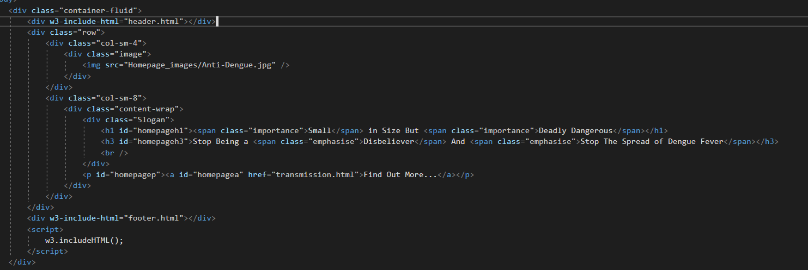

Figure 1: Homepage HTML

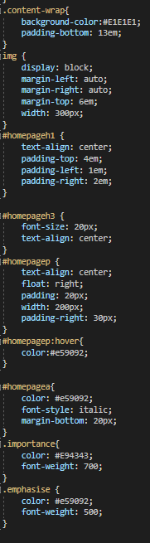

Figure 2: Homepage CSS

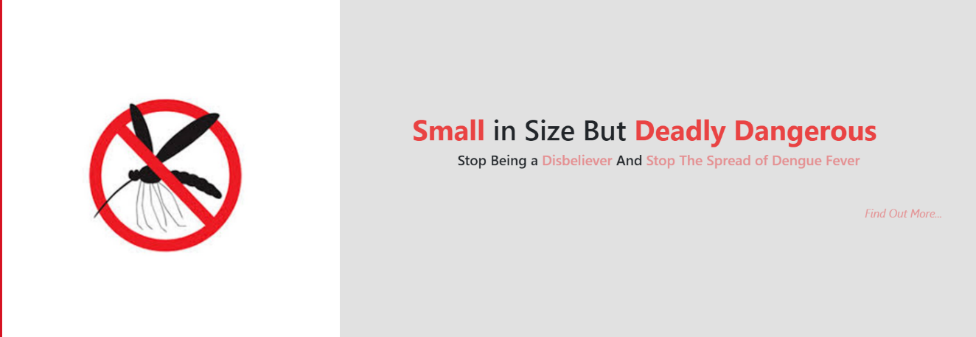

Figure 3: Homepage Example

# Header (Menu) Discussion

The header is decorated with a pink background, #F4C2C2. The header has a title that shows our group name “DengueFever” in the middle, as well as navigation links to the next website. These links at the bottom of the title and have a reddish-pink border. The words have the same colour as the border, and provides nice contrast against the pink background. An additional feature of the header is that there is an ICT logo with the text “Taking IT higher” beside the logo. The logo is also spinning continuously on the spot.

The header has six navigation links, starting with the furthest left, “home” links to the homepage. The next header item is “Transmission” which links to the webpage sharing about what is Dengue and how it is transmitted. The third header item is “Effects”, which links to the webpage sharing about dengue fever which is transmit by dengue mosquito, the symptoms of dengue fever and the risk associated with it because of the effect of symptoms. The fourth header item is “Strategies”, which links to the webpage sharing about the strategies that the government had used, as well as strategies on how individuals can use to fight Dengue. The fifth header item is “Trends”, which links to the webpage sharing about the trends and statistics relating to Dengue in Singapore. The last header item is “References” where it shows all of our references. Refer to Figure 4 for the HTML Code used for creating the header, Figure 5 – 7 for the CSS Code, and Figure 8 for an example of how the header looks like.

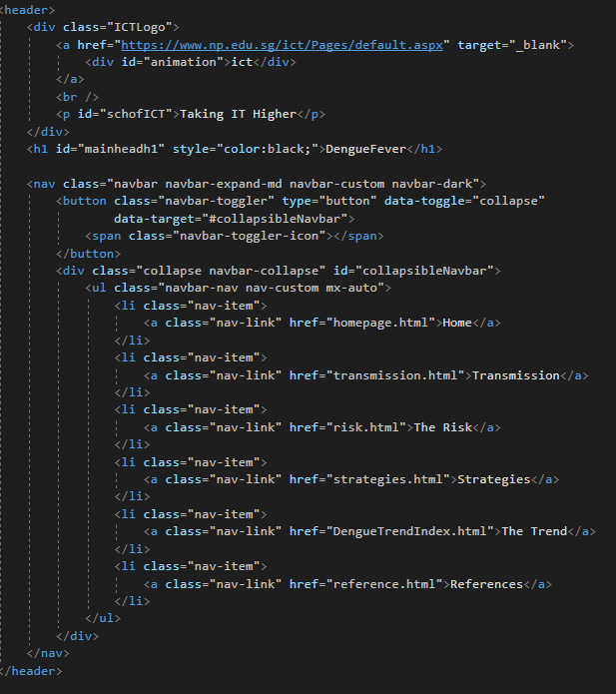

Figure 4: Header HTML Code

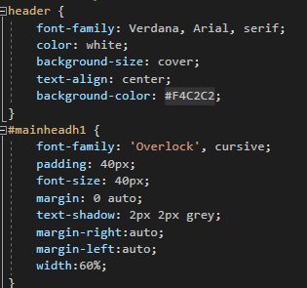

Figure 5: Header Background & Text CSS

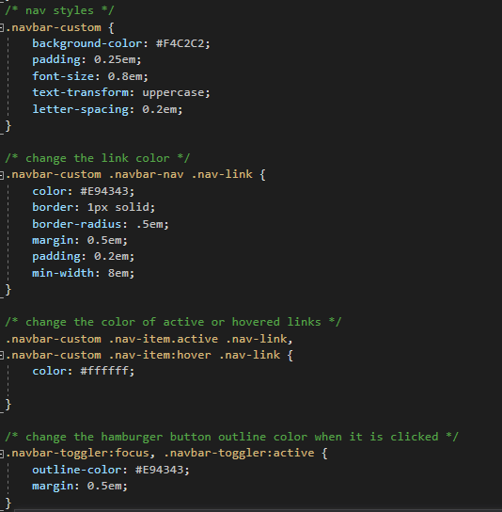

Figure 6: Header Navigation Links CSS

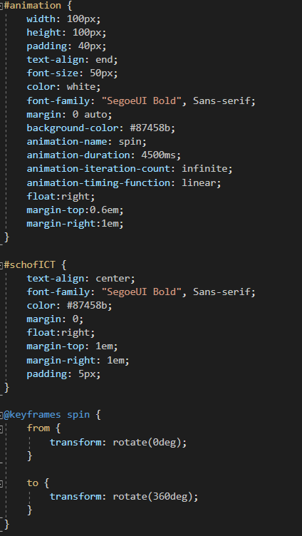

Figure 7: Header Animation CSS



Figure 8: Header Example

# Footer Discussion

For footer, the contents we have included are, our team name and team member’s name. As for the styling, we have used our standardised font-colour, font-style, and font-family with a slight grey text-shadow around the letters.



*Figure 1: Footer in webpage*

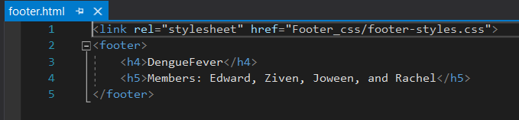

*Figure 2: Footer html code*

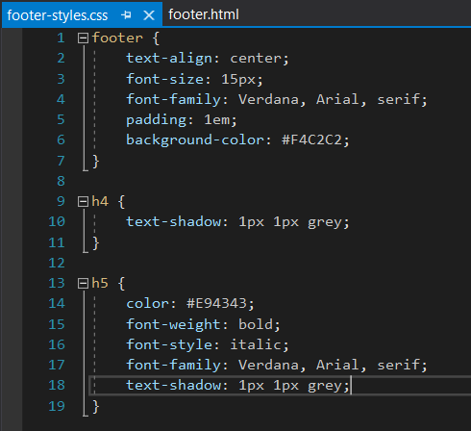

*Figure 3: Footer css code*

# List Members and Assigned Tasks

|  |  |
| --- | --- |
| Member | Tasks |
| Edward | * Strategies to curb the spread of Dengue * Home Page |
| Ziven | * Dengue Trend * Header |
| Joween | * Risk and Symptoms of dengue * References Page |
| Rachel | * Transmission of dengue * Footer |

# Member 1 (Edward)

## Webpage Content

My webpage covers the strategies to prevent the spread of Dengue. I have divided the webpage into 5 sections - Introduction, Efforts Made by the Government, Individual's Efforts, Activities, and Feedback.

The introduction places emphasis on the seriousness of Dengue, as well as an explanation about the purpose of creating this section of the website. Figure 1.1.1 shows how the introduction looks like. The key message here is to raise awareness about the dangers of Dengue and to share how everyone could play a part to stop the spread of Dengue.

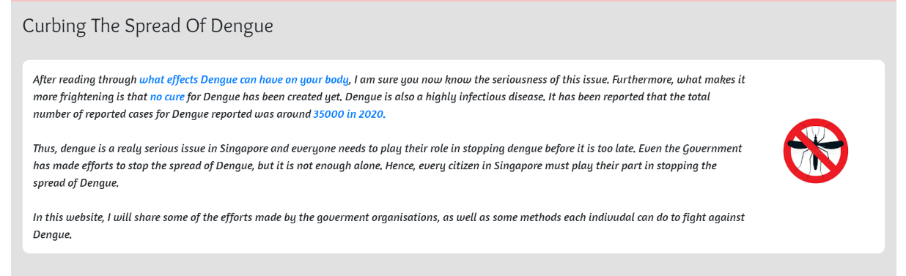

Figure 1.1.1: Introduction

To emphasise how important the issue is for the community, I highlighted how the government is trying to solve the issues of Dengue and how various government organisations have played an active role in the fight against Dengue. All these are featured in the second section. Figure 1.1.2 and Figure 1.1.3 shows how the section looks like.

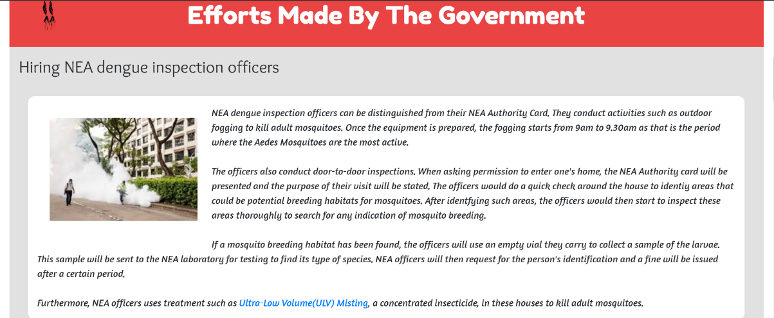

Figure 1.1.2: Government’s Efforts First Half

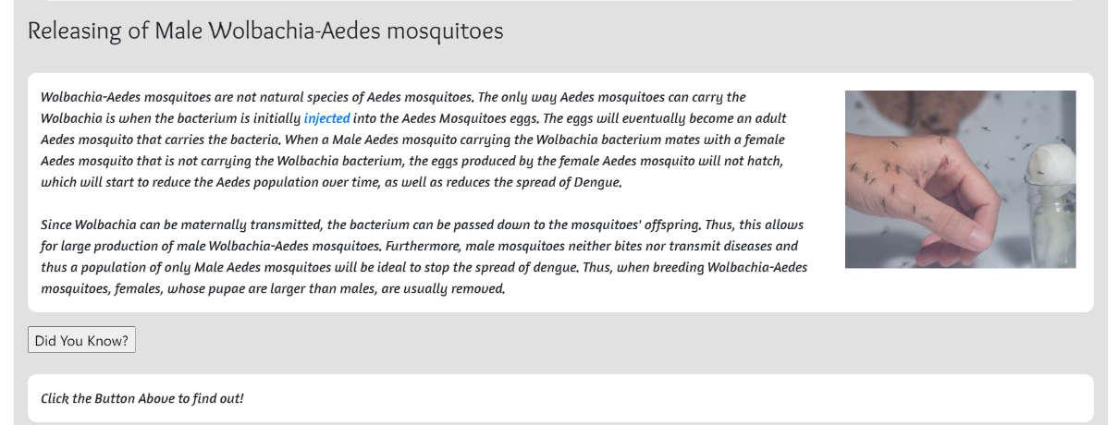

Figure 1.1.3: Government’s Efforts Second Half

For the third section, it explains what individuals can do to help fight against Dengue. Figure 1.1.4 and Figure 1.1.5 shows how this section looks like.

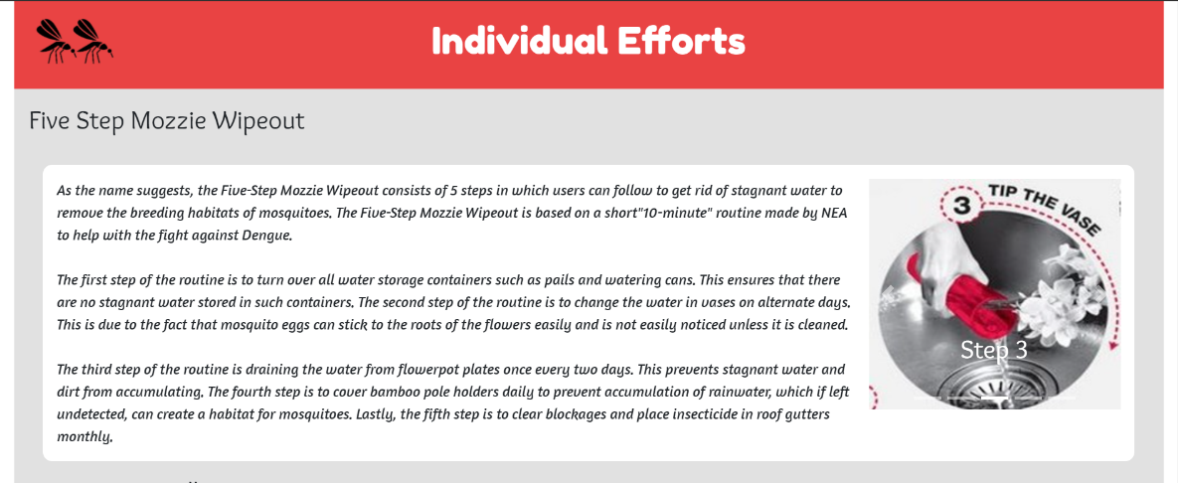

Figure 1.1.4: Individual Efforts First Half

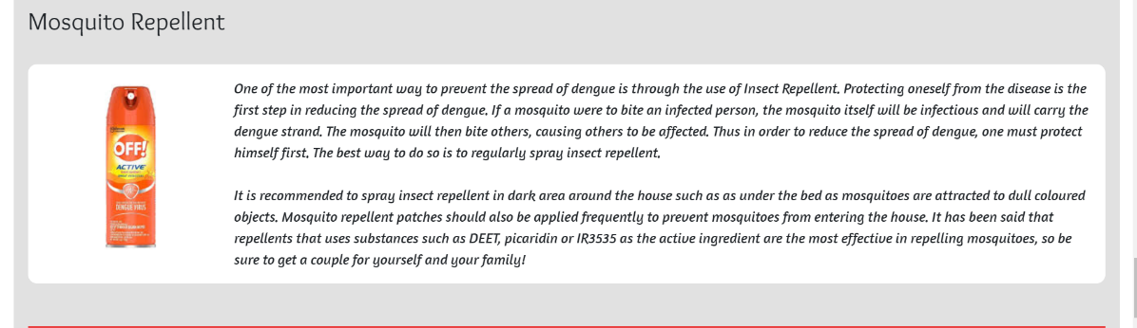

Figure 1.1.5: Individual Efforts Second Half

For the fourth section, it provides a blow-by-blow detail of the actions individuals can take to fight against Dengue. Figure 1.1.6 shows how this section looks like.

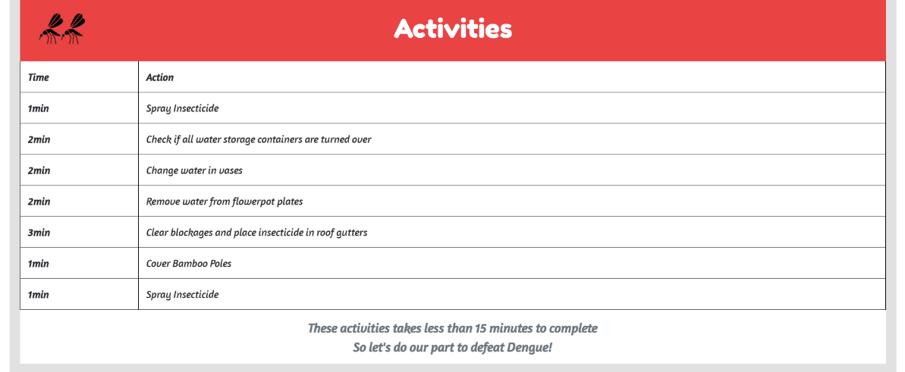

Figure 1.1.6: Activities Table

Lastly, for the fifth section, it contains a feedback form where users can put in suggestions for improvements or complaints. There are also two links at the end. The hyperlink on the left links to the previous webpage, while the one on the right directs users to the next webpage. Please refer to Figure 1.1.7 below.

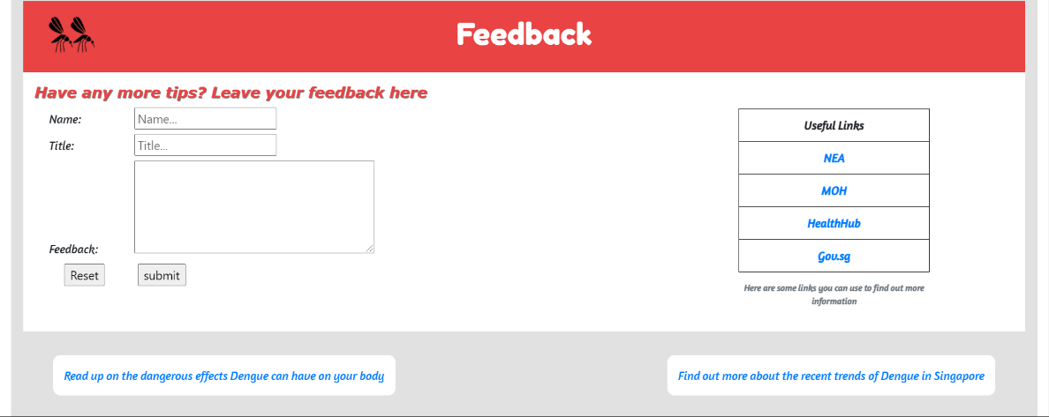

Figure 1.1.7: Feedback Form + Links

## Header/Footer Inclusion

## I have kept the header and footer uniform with the rest of the webpages to ensure consistency. The pink colour of the header and footer also provides a vibrant overall look to my webpages as it blended well with the main colours of my website which are grey and white.

## Responsive Element

For the Responsive element in my website, I used “class = ‘row’” to separate each content by rows and used “class = ‘col-sm-12'” to ensure that the content takes the whole width of the webpage. I also used “class = ‘container-fluid'” to make the whole webpage responsive. Refer to Figure 1.3.1 to view the HTML Code used and Figure 1.3.2 for an example of a resized webpage view.

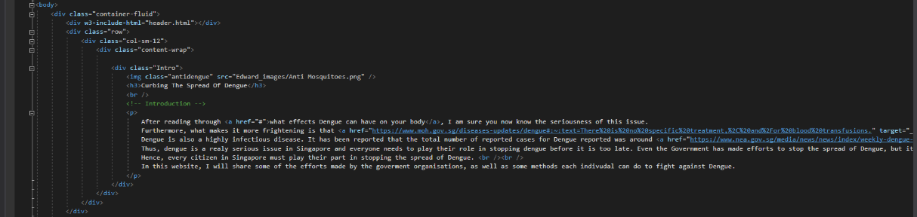

Figure 1.3.1: Responsive HTML Code

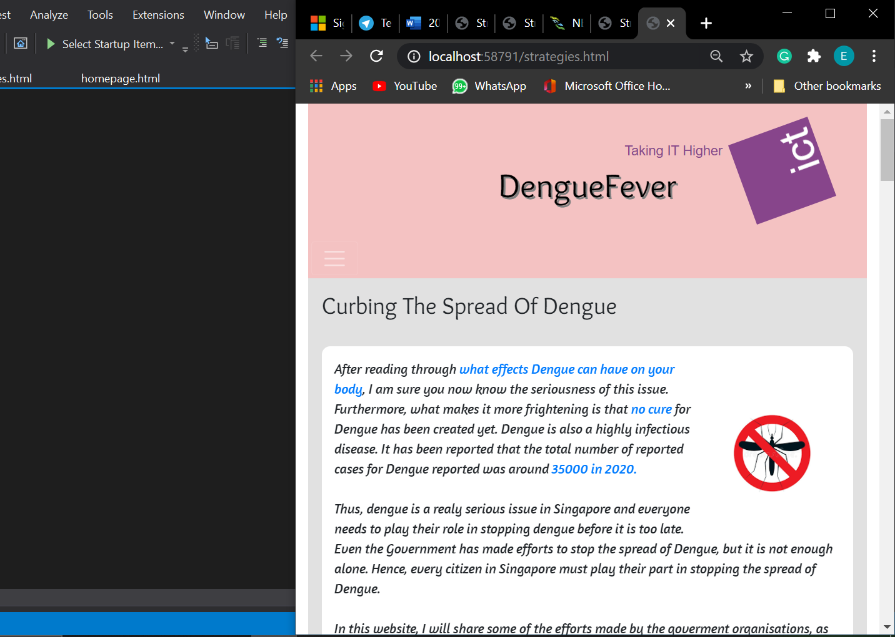

Figure 1.3.2: Responsive Web Example

## Javascript/JQuery Implementation

The first noticeable things I have added is 2 picture carrousels, one under the “Efforts Made by The Government” section, and one under the “Individual Efforts” section. The first carousel shows 4 images of NEA officers checking for mosquito habitats and fogging. The second carousel shows the 5 steps for the Mozzie Wipeout. Figure 1.4.1 shows the HTML Code for the carousel for NEA Officers and Figure 1.4.2 shows the HTML Code for the carousel for Mozzie Wipeout. To see the images please refer to 1.6.3 - 1.6.6 for NEA Officers images. For Mozzie Wipeout steps, please refer to 1.6.8 - 1.6.11.

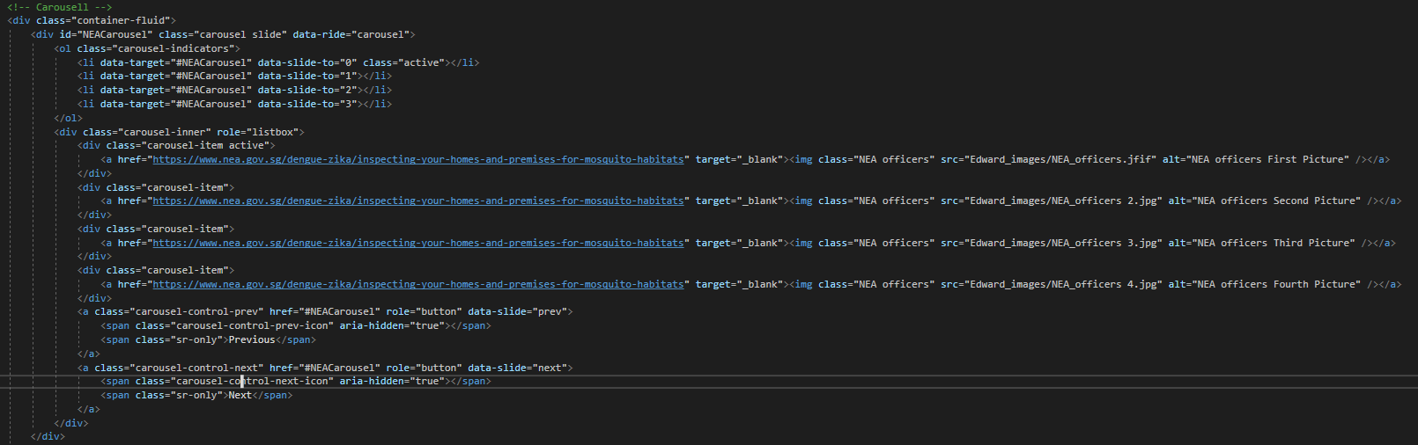

Figure 1.4.1 Carousel HTML (NEA Officers)

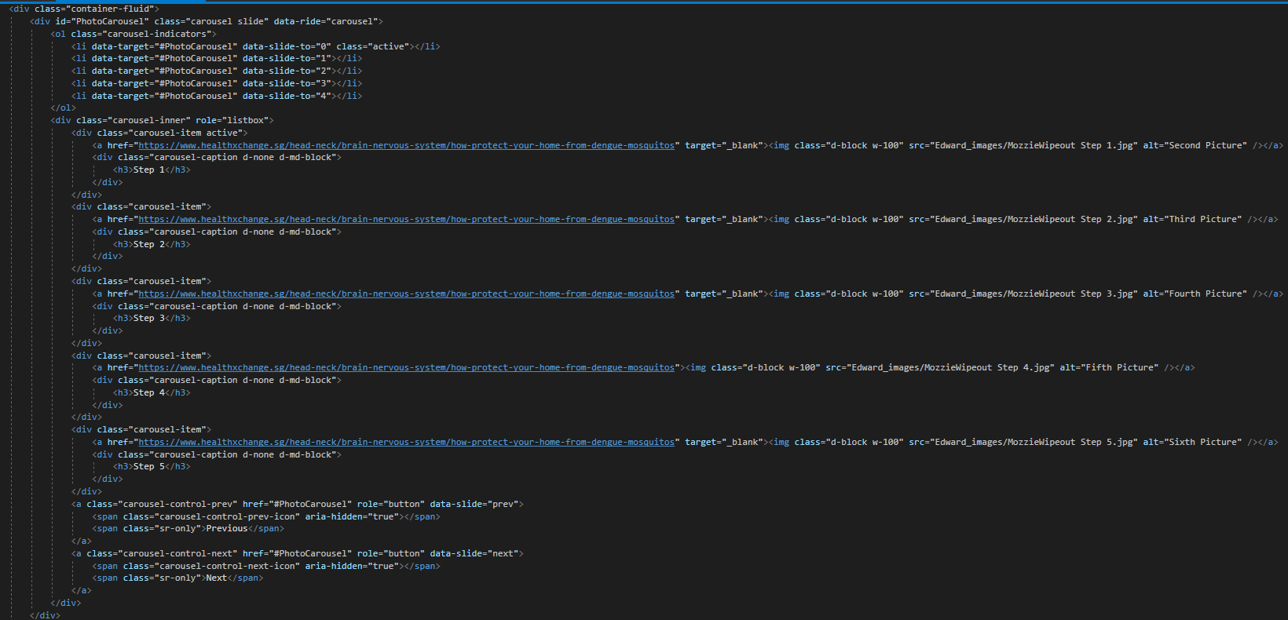

Figure 1.4.2: Carousel HTML (Mozzie Wipeout)

The next Javascript implementation I had was a “Did You Know?” button, after the section on “Male Wolbachia–Aedes Mosquitoes”. After users click on the button, a string of text will be inputted into the paragraph element in html below the button. This string of text represents a statistic relating to the Male Wolbachia-Aedes Mosquitoes. Figure 1.4.3 shows the HTML Code and Figure 1.4.4 shows the JavaScript Code.

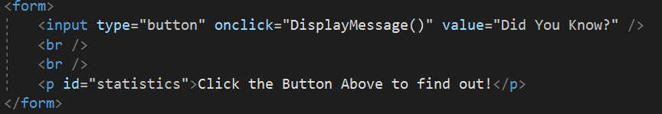

Figure 1.4.3: Did You Know? (HTML)



Figure 1.4.4: Did You Know? (JavaScript)

The last thing I had to use Javascript for is “submit” and “reset” buttons for my form. Although I could input buttons in without the use of Javascript, the buttons would refresh the whole page, and this can prove quite an inconvenience for users. Thus, I used Javascript commands to clear all values inserted by the users for the “reset” button. After users filled in information in all areas of the feedback form and clicked on the “submit” button, then a thank you statement will be displayed. Figure 1.4.19 and Figure 1.4.20 shows the HTML code and the JavaScript Code. Please refer to Figure 1.7.3 - Figure 1.7.5 to view the form.

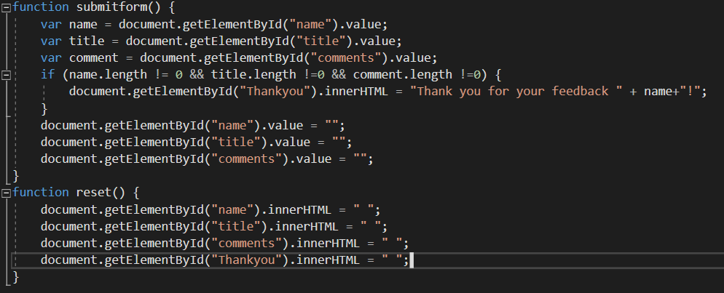

Figure 1.4.5: Feedback Form (JavaScript)

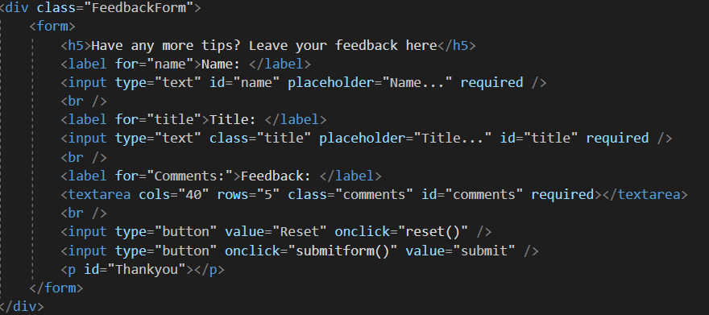

Figure 1.4.6: Feedback Form (HTML)

## External Stylesheet

I have grouped most of my content in a class called “content-wrap”. Content-wrap has a light-grey background that is represented by the hex digits, #E1E1E1. Furthermore, in content-wrap there is a p element that a rounded-radius border, as well as padding to give it a cleaner look, so as to prevent it from looking too cluttered. The element also has a white background, which provides contrast with the grey background from the content-wrap. This also places emphasise on the paragraphs. There is also a h3 element that is used as a sub-header for each paragraph of information. Please refer to Figure 1.5.1 for the CSS Code, and Figure 1.1.5 to see how it looks like on the website.

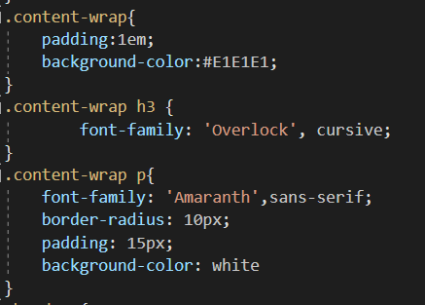

Figure 1.5.1: Content-Wrap CSS

There is a header class which represents which section the user is currently at. The header has a red background with the hex code of #E94343, and the words in the header is white in colour. The white complements the red. The red background also fits well with the pink headers, and footers, as well as with the grey content-wrap and white paragraph element.

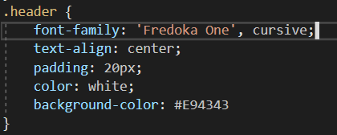

Figure 1.5.2: Header Class CSS



Figure 1.5.3: Header Example

I also standardised with my groupmates on the fonts we used. We used the font, “Fredoka One”, for main headers, “Overlock” for sub-headers, and “Amaranth” for paragraphs and other elements such as label, caption, tr, th, and td. Please look at Figure 1.5.4.

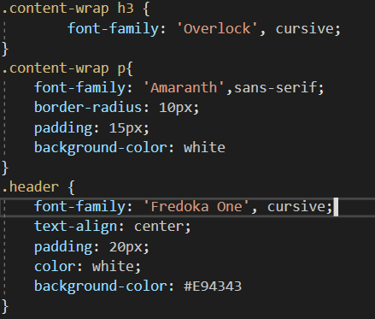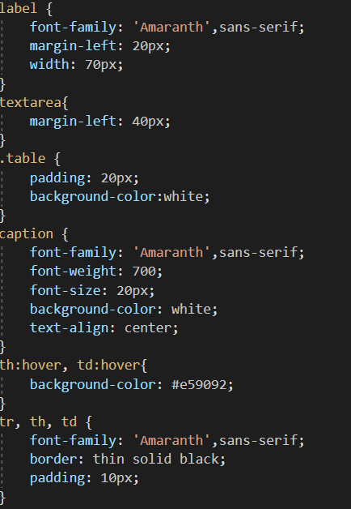

Figure 1.5.4: Font usage

The images and carousels are also organised to the left of each paragraph or to the right of each paragraph and has padding to prevent it from looking it too clustered. Please refer to Figure 1.5.5 for the CSS Code Example.

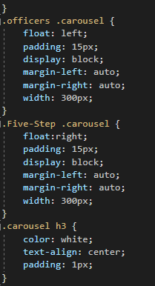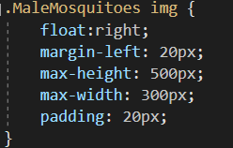

Figure 1.5.5: Images + Carousel CSS Example

The tables in the webpages have a white background and thin black borders. Another feature is that when the elements are hovered over, the elements will have the background-colour similar to the pink used for the header and footer. Figure 1.5.6 shows the CSS Code for the tables and Figure 1.5.7 shows an example of how the table looks like.

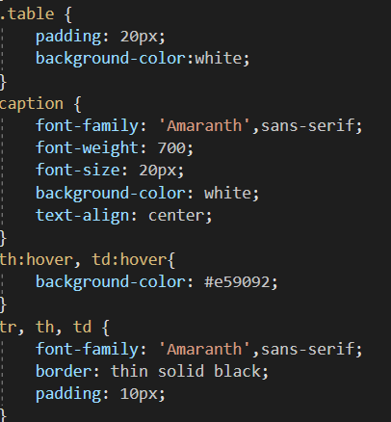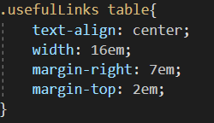

Figure 1.5.6: Both Tables CSS Code

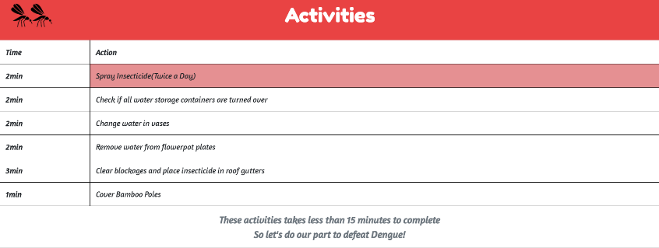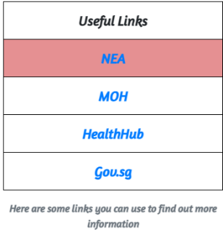

Figure 1.5.7: Activities Table (Left) & Useful Links Table (Right)

The feedback form has a white background and its labels, input and text area elements are organised ensure that they are positioned correctly. Please refer to Figure 1.5.8 to see the CSS Code and Figure 1.7.3 to see how the form looks like.

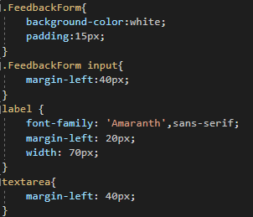

Figure 1.5.8: Feedback Form CSS

## Animation & Multimedia

For the animations in my webpage, I have used two identical pictures of mosquitoes, placed them side by side and used @keyframes to make them flip around. I had to use transform: perspective() and ScaleX() to flip it. These mosquitoes are placed on the left-hand side of every header. Figure 1.6.1 shows how the mosquitoes look like.



Figure 1.6.1: Mosquito Icons

I have also included multiple images throughout my website. The first picture is an Anti-Dengue logo which is in the introduction as seen in Figure 1.6.2 below.

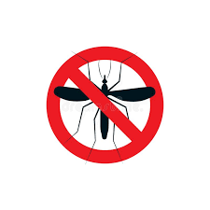

Figure 1.6.2: Anti-Dengue Logo

The next few images are in a carousel that shows National Environment Agency (NEA) officers conducting their checks and fogging. Users can click on either of these four images to learn more about what NEA officers do. The images are shown in Figure 1.6.3 to Figure 1.6.6 below.

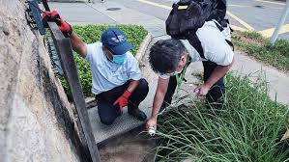 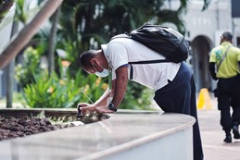

Figure 1.6.3: NEA Officers Pic 1 Figure 1.6.4: NEA Officers Pic 2

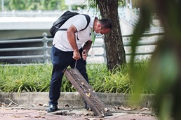 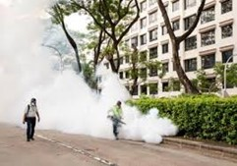

Figure 1.6.5: NEA Officers Pic 3 Figure1.6.6: NEA Officers Pic4

The next image shows a swarm of male Aedes Mosquitoes around a hand, further emphasising that male mosquitoes do not suck blood of humans. Clicking on the image will redirect users to another page to find out more about the mosquitoes. The image used can be seen in Figure 1.6.7 below.

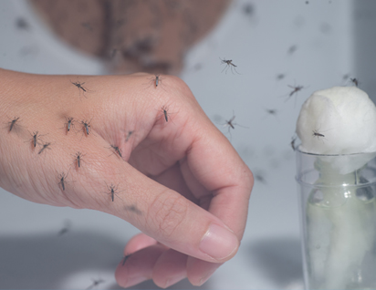

Figure 1.6.7: Male Mosquitoes Swarming Hand

In addition, there is another carousel with five images that shows the five steps in the Mozzie-Wipeout. Users can click on any of the five images to be redirected to another page to find out more about these steps. The images used can be seen in Figure 1.6.8 - Figure 1.6.12.

 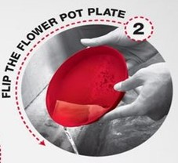

Figure 1.6.8: Mozzie Wipeout 1 Figure 1.6.9: Mozzie Wipeout 2

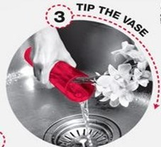 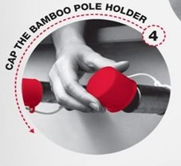

Figure 1.6.10: Mozzie Wipeout 3 Figure 1.6.11: Mozzie Wipeout 4



Figure 1.6.12: Mozzie Wipeout 5

Lastly, the last image in my webpage is a picture of a mosquito repellent, when users click on the picture, it will bring them to a webpage where they can buy that specific mosquito repellent from. Figure 1.6.13 below shows the example of the mosquito repellent shown.

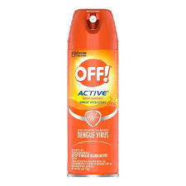

Figure 1.6.13: Insect Repellent

1. Form Implementation

For my implementation of forms, I have used two forms, one small one to input a button in which users can click to find out more about the Male-Wolbachia Mosquitoes. Figure 1.7.1 shows how the button before being pressed and Figure 1.7.2 shows what happens after the button is pressed.



Figure 1.7.1: Did You Know?

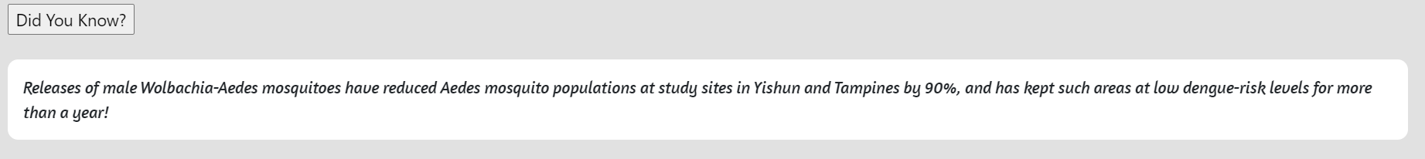

Figure 1.7.2: Did You Know? (After Button is Pressed)

Another form I used is at the end of the webpage to get user’s feedback. It has 3 labels, “Name", "Title”, and “Feedback”. For “Name” and “Title”, they both have inputs with placeholder tags. For “Feedback”, I used text area with cols as 40 and rows as 5. Figure 1.7.3 shows an example of the form. Figure 1.7.4 shows an example of the form after the reset button is clicked and Figure 1.7.5 shows an example of a submission.

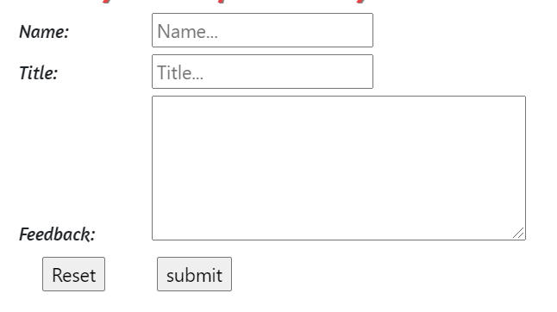

Figure 1.7.3: Feedback Form

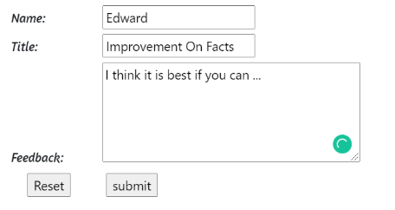 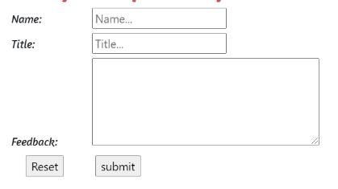

Figure 1.7.4: Feedback Form (Reset is Clicked)

 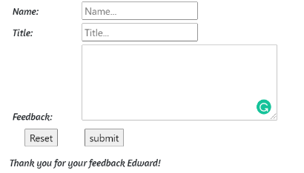

Figure 1.7.5: Feedback Form (Submitted)

# Member 2 (Ziven)

## Webpage Content

My webpage consist of the trends in Dengue cases. My webpage is split into 5 sections, the trend, the region with the most prominent Dengue cases, the reason for the increase in cases, Singapore’s cases, a video explaining more about Dengue spikes and a table of the past Dengue cases. At the end of each paragraphs, I added a small number linking to relevant websites we referred to.

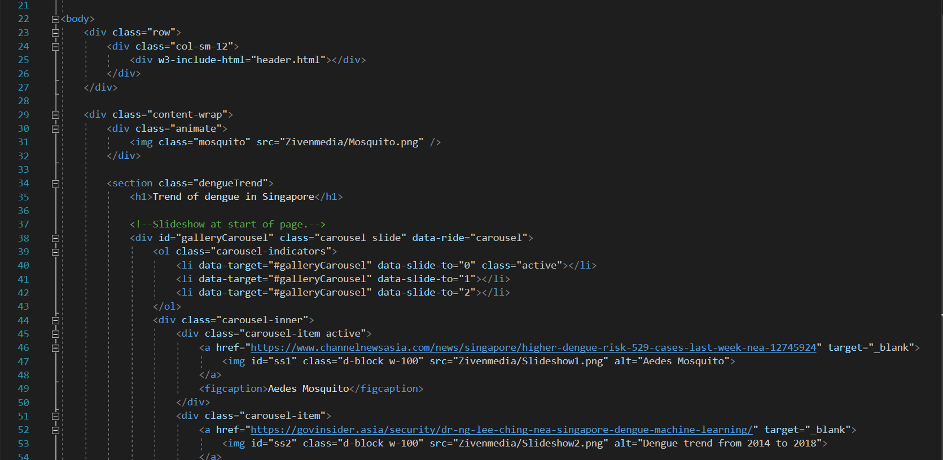

Figure 2.1.1: A snippet of the code on my webpage content

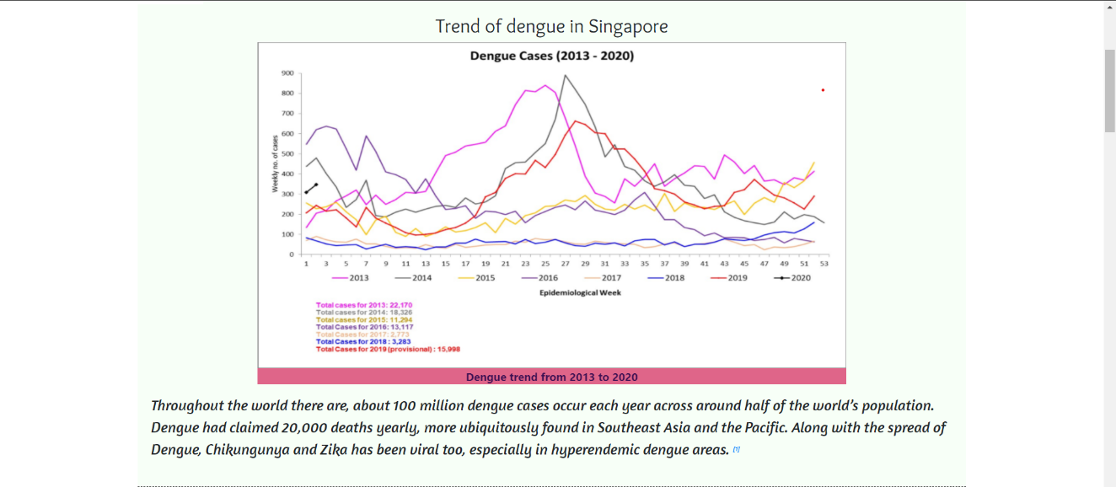

Figure 2.1.2: A snippet of the content on my webpage content

## Header/Footer Inclusion

My teammates and I agreed that the header and footer’s colour should be uniform with our page colours, which we decided to make the background pink, fonts as black and red, and added shadows to the footer’s fonts. We also included a custom font from Google, which will be covered in 2.5 External Stylesheet. Moreover, we have an animated ICT logo, representing the school with the school’s slogan “Taking IT Higher”, which will be covered in 2.6 Animation & Multimedia.

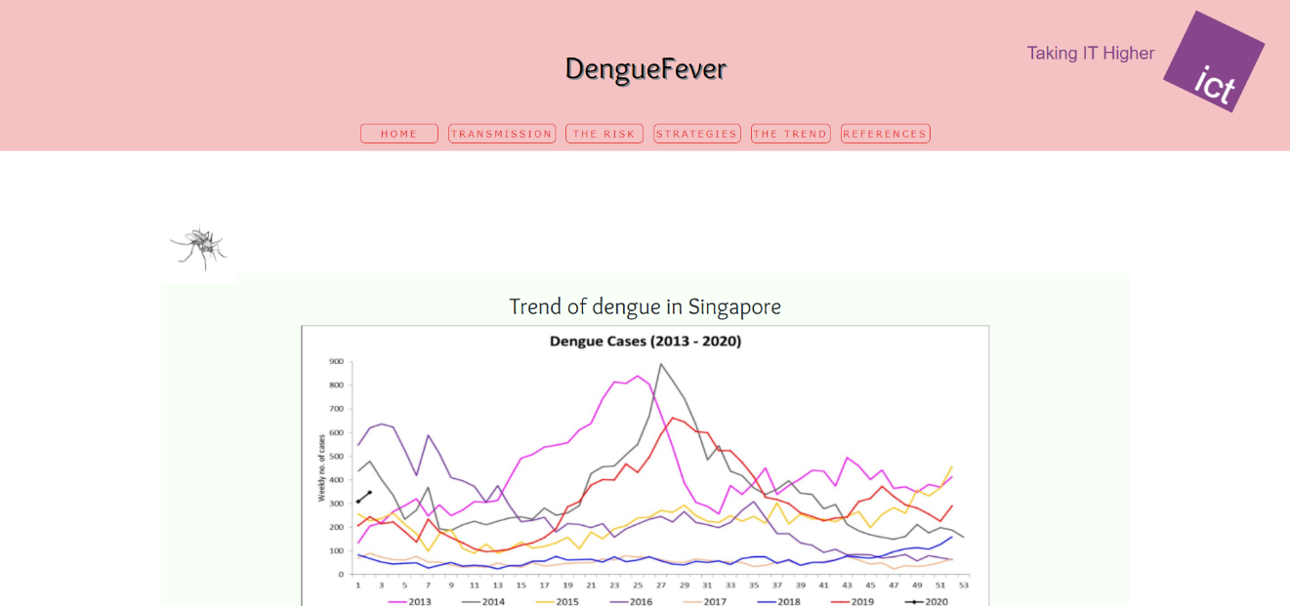

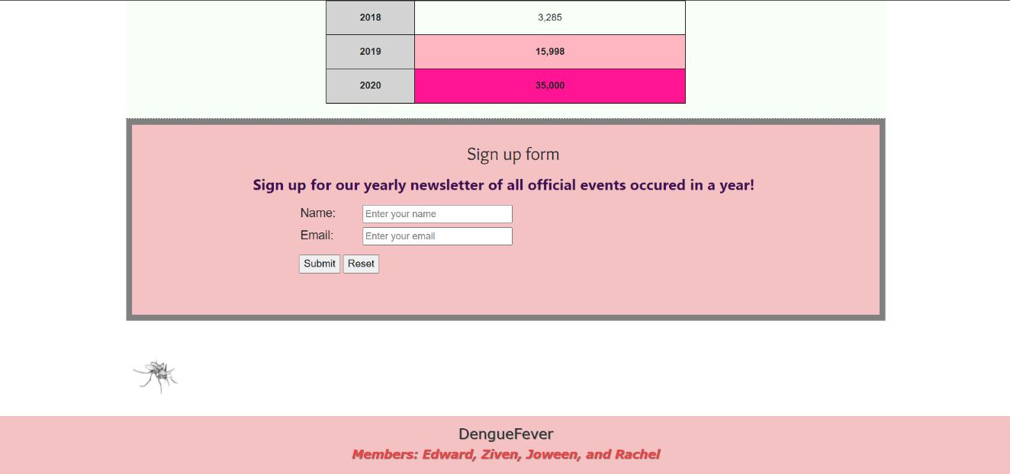

Figures 2.2.1, 2.2.2: A snippet of the header and footer.

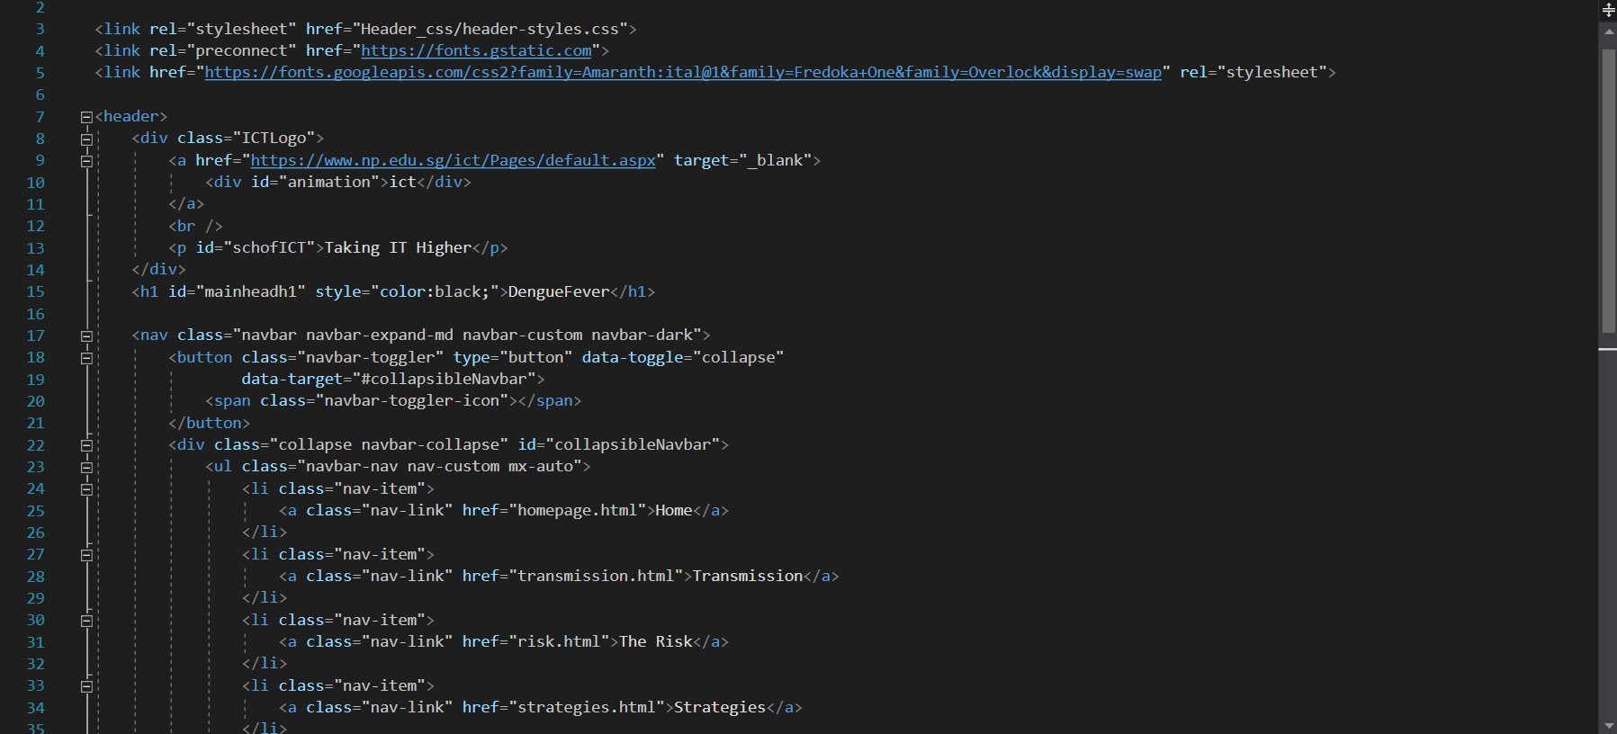

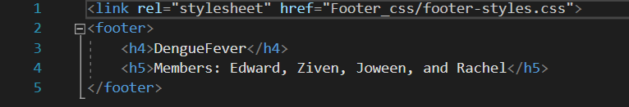Figures 2.2.3, 2.2.4: A snippet of the code for our header and footer.

## Responsive Element

For responsive elements, I decided to go with “@media only screen and ()” as I am using “content-wrap” for my webpage and not “container-fluid” as I feel that “content-wrap” makes my webpage look much neater.

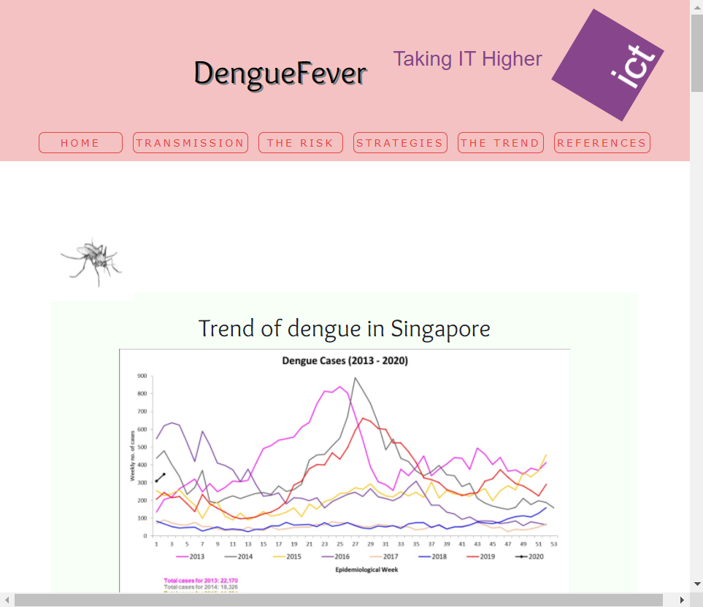

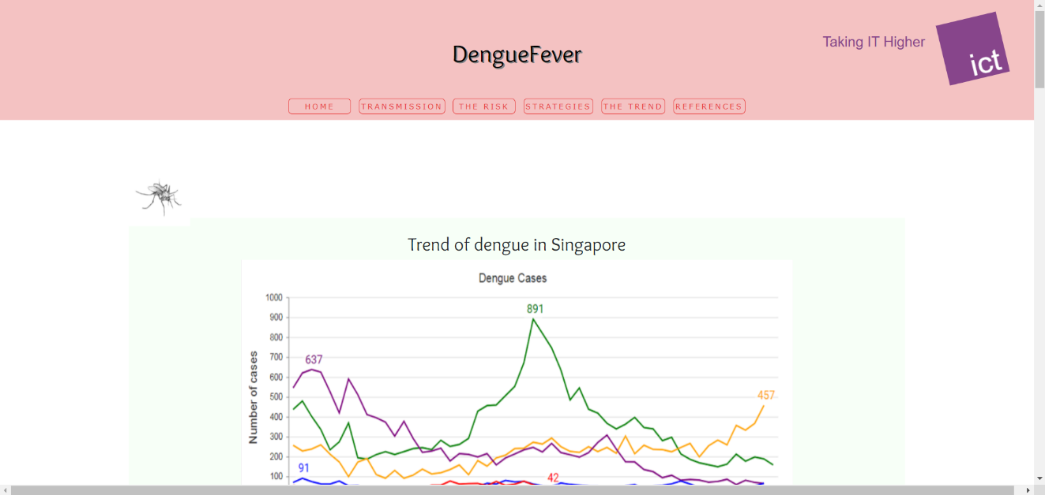

Figures 2.3.1, 2.3.2: A snippet of the responsive element on the webpage.

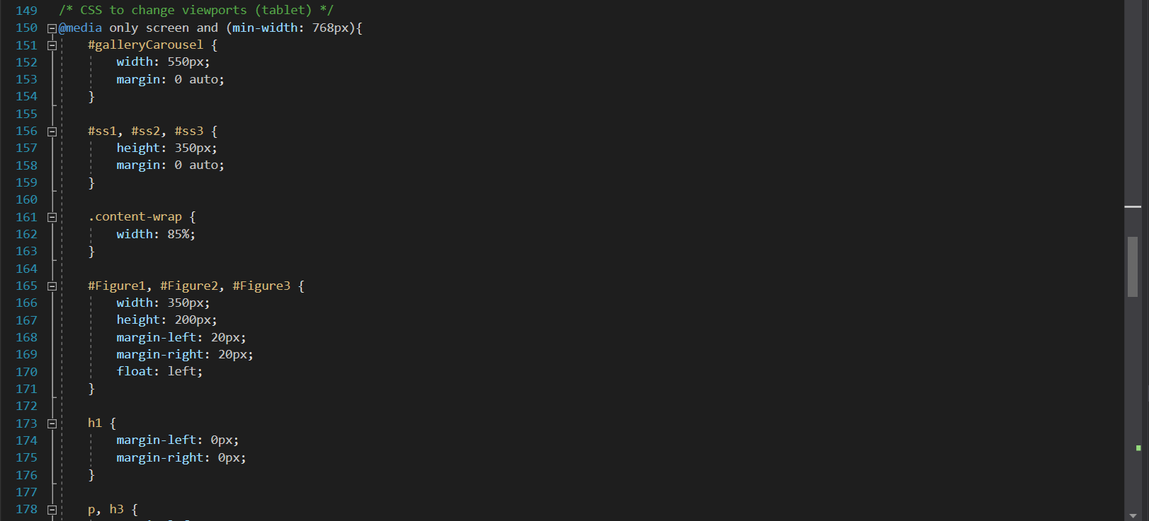

Figure 2.3.3: A snippet of the code for the responsive element.

## Javascript/JQuery Implementation

For Javascript/JQuery Implementation, I added a slideshow at the start of my webpage, that shows a picture of a mosquito and 2 graphs that shows the number of cases from 2013 to 2020. I also added a “contactUs.js” for my form to take in subscribers’ name and email, sending them a thank you message for signing up. More details would be explained in 2.7 Form Implementation.

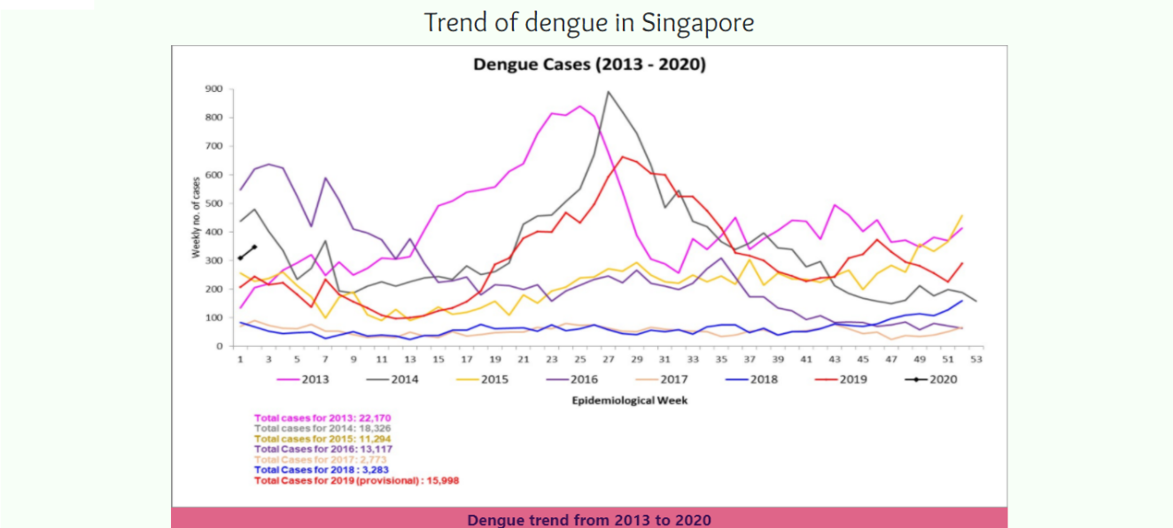

Figure 2.4.1: A snippet of the slideshow on my webpage.

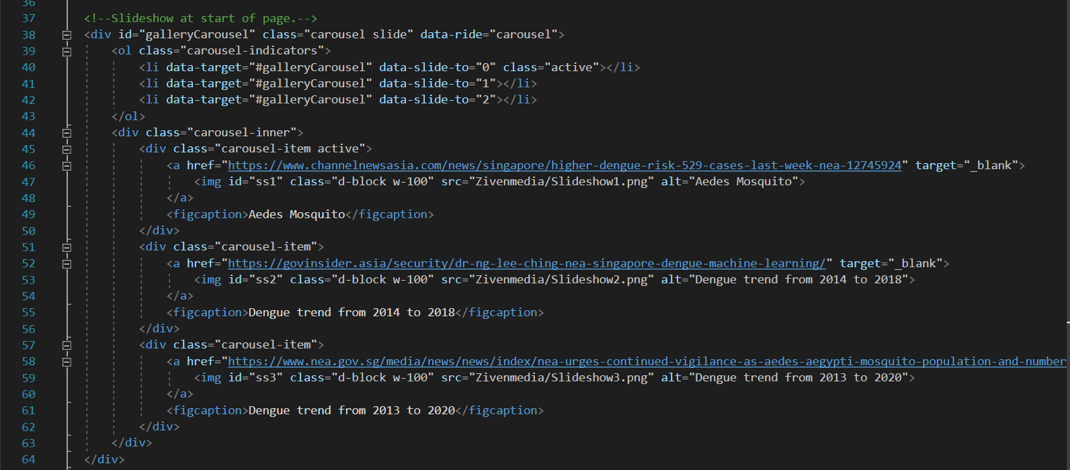

Figure 2.4.2: A snippet of the code of the slideshow.

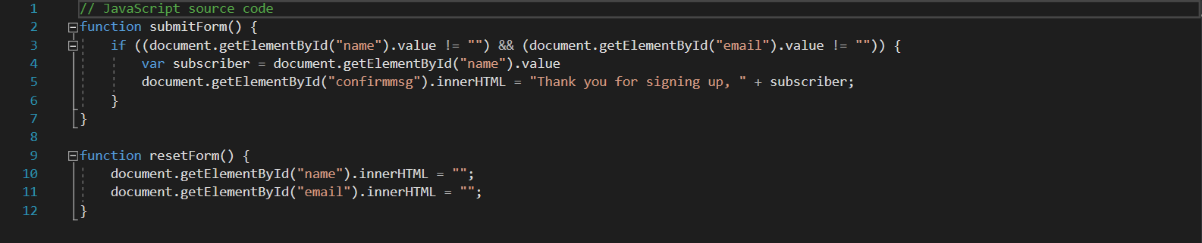

Figure 2.4.3: The code for the form (Zivenjs/contactUS.js).

## External Stylesheet

Firstly, my team and I created multiple folders for standardised stylesheets. We added “Header_css” and “Footer_css” stylesheet folders for the header and footer respectively. A “Homepage_css” stylesheet folder for the homepage and “Bootstrap” folder that contains the bootstrap stylesheets for our responsive elements, slideshows, etc.

Next, I added “DengueTrendStyles.css” and “FormStyles.css” in my “Zivencss”” folder for my webpage. Throughout our stylesheets, we have established our webpage with different paddings, margins, width and height of our elements, displays, font styles, weights and sizes, alignment of text and colour for different sections and divisions of our page

In the header and footer stylesheets, as mentioned, our team went with the theme colour, pink, red, black, white and grey. We chose pink for the background of both header and footer, red for our members’ names as it represents passion to our work, black for the fonts for boldness and grey for the shadows of the words. We also have a special font from Google for the header’s heading, which will be covered later. When the buttons on the navigation bar is hovered upon, it will turn white.

For my webpage, I used the colour #F4C2C2 (pinkish red) for the fill of the form, #3C1053FF (purple) for the confirmation message, and #808080 (grey) for the border of the form. #E1E1E1 (faint grey) for the content wrap. I also used the same pinkish red and light pink for the table of past Dengue cases. I also used the purple and #DF6589FF (dark pink) for the figure caption of the carousel.

In agreement with my teammates, we decided to import Google fonts of Amaranth, Fredoka One, Overlock. We used Overlock font for the main headers, Fredoka One font for the sub headers, and Amaranth font for the paragraphs. We decided to use these fonts as Amaranth is striking, capturing the eye of readers to read on, Fredoka One with a heavy font from Google, to give off the cue to a next section or paragraph and Overlock as it is elegant, fitting for the title.

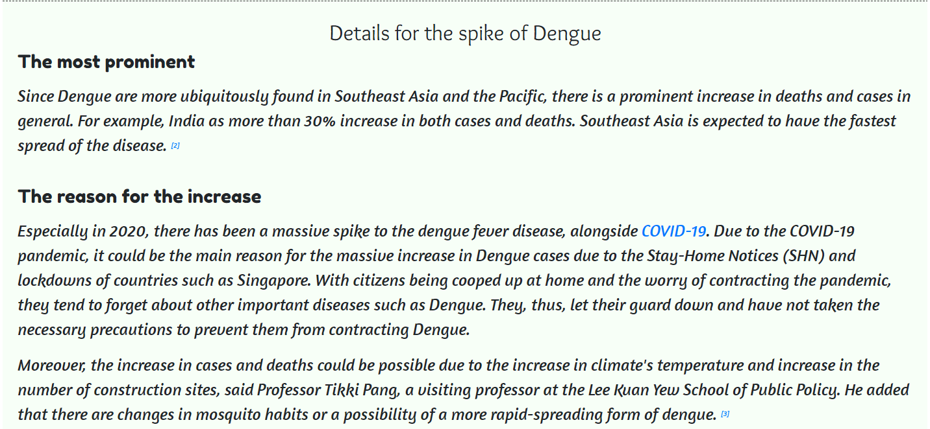

Figure 2.5.1: A snippet of the 3 fonts we used. (Themed colours shown in previous figures)

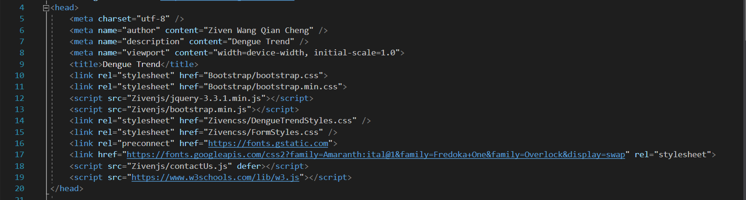

Figure 2.5.2: A snippet of the code for importing Google Fonts and stylesheets.

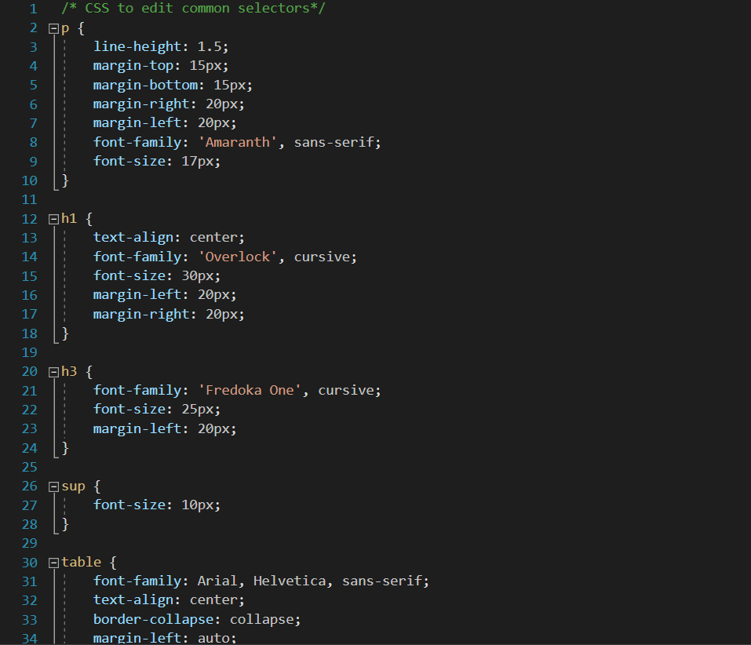

Figure 2.5.3: A snippet of one of my two stylesheets’ codes.

## Animation & Multimedia

To start off section 2.6 Animation & Multimedia, we have the ICT Logo in the header spinning infinitely. We wanted to include our school’s logo to represent, however, the stale stationary logo was not of our liking as it would not entice the readers. We wanted2 to make it unique, therefore with the code “transform: rotate()” and “@keyframes spin”, we can make the logo spin 360 degrees continuously with “animation-iteration-count: infinite;”.

Next is the two mosquitoes bobbing up and down at the top and bottom of the page. To make this possible, I needed another “@keyframes moveMosquito” and “transform: translateY()” to change the Y-axis of the mosquito.

I also added a YouTube video from CNA that describes more about the spike in Dengue cases. I included a link to reference to the actual video.

Each pictures, including the ones in the slideshow, would also reference to the relevant websites that were taken from.

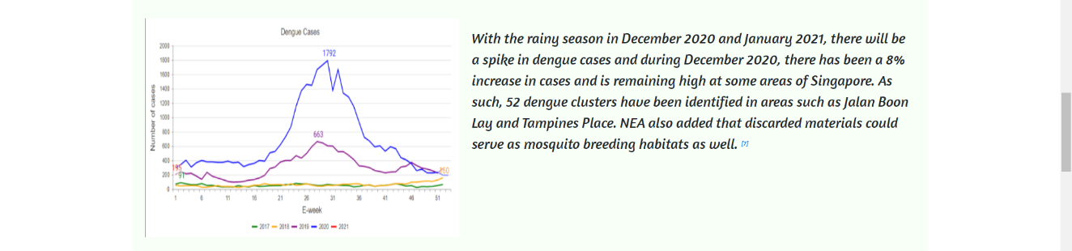

Figure 2.6.1: A snippet of the picture I added for multimedia.



Figure 2.6.2: A snippet of my code used to insert pictures on my webpage.

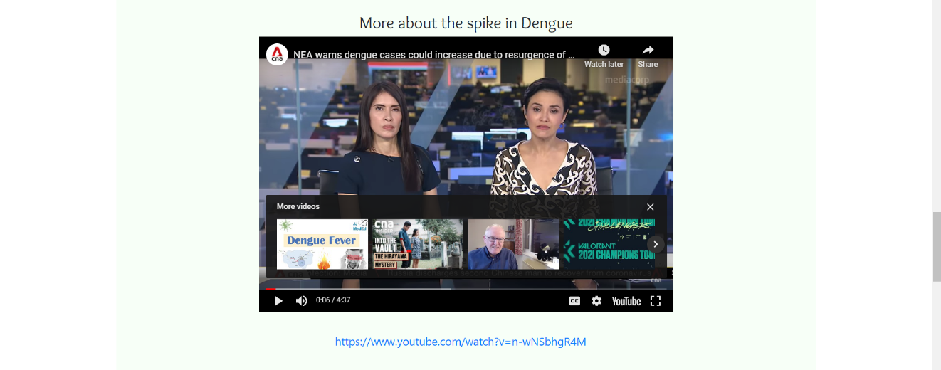

Figure 2.6.3: A snippet of the embedded video for multimedia.



Figure 2.6.4: A snippet of how I embedded the video.



Figure 2.6.5: A snippet of the mosquito I used for bobbing animation.



Figure 2.6.6: A snippet of the logo for our header.

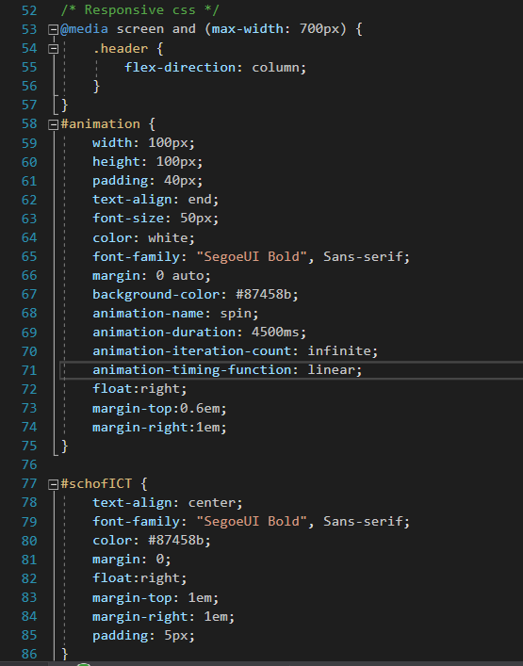

Figure 2.6.7: A snippet of one of the animations (logo).

## Form Implementation

I have implemented a form that would collate subscribers’ email and name for those that sign up for our “newsletter”. Upon submission, they will be greeted with a confirmation message, and the webpage would not refresh, thus allowing them to continue with other sections of our website.

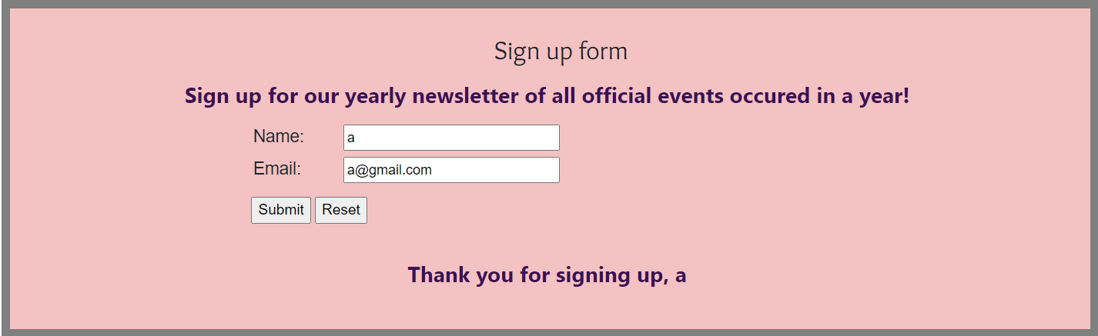

Figure 2.7.1: A snippet of my form on my webpage.

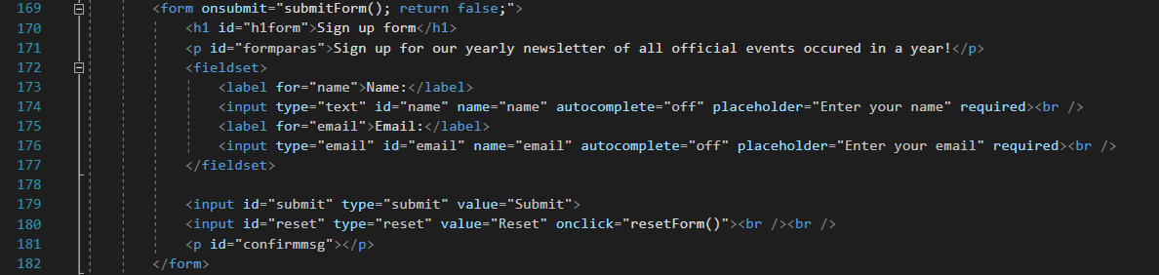

Figure 2.7.2: A snippet of my code for the form.

# Member 3 (Joween)

## Webpage Content

**1. Introduction (What is dengue fever)**

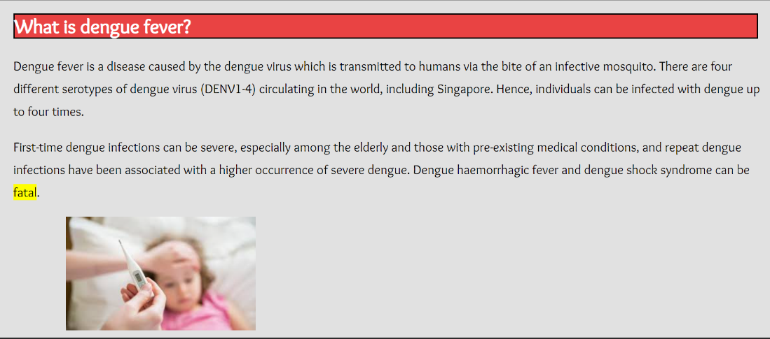

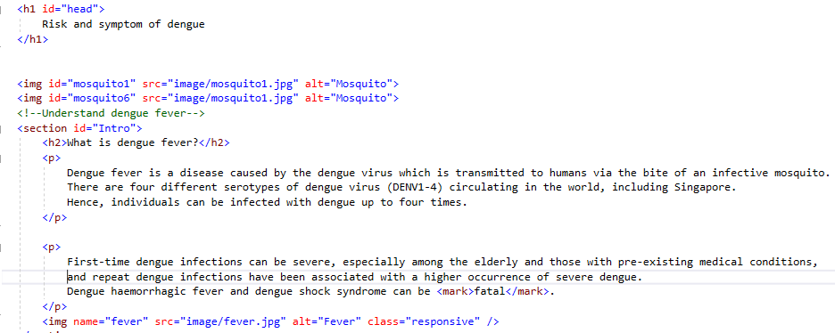

**2. What are the symptoms of dengue fever?**

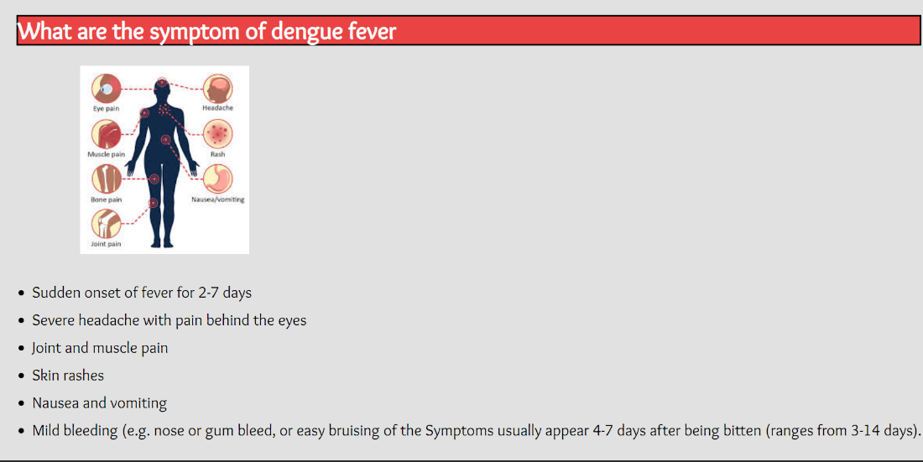

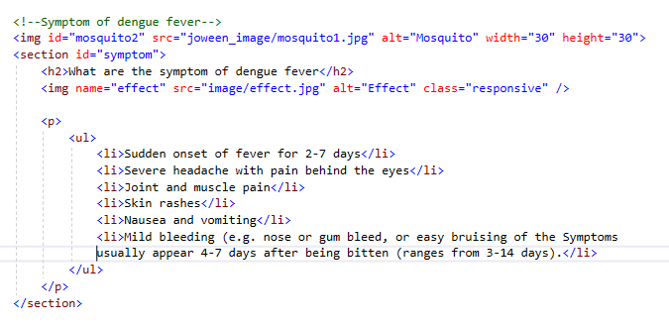

**3. What is the risk associated with dengue fever?**

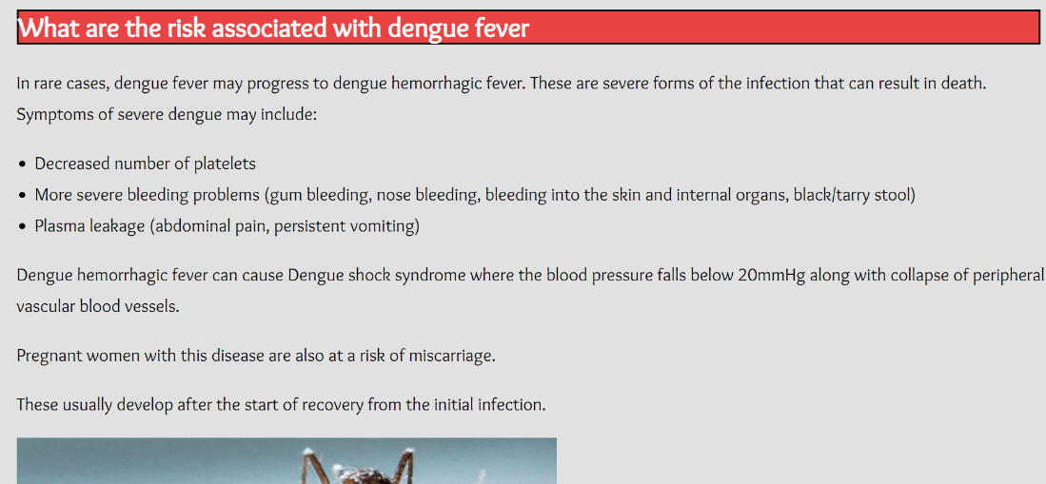

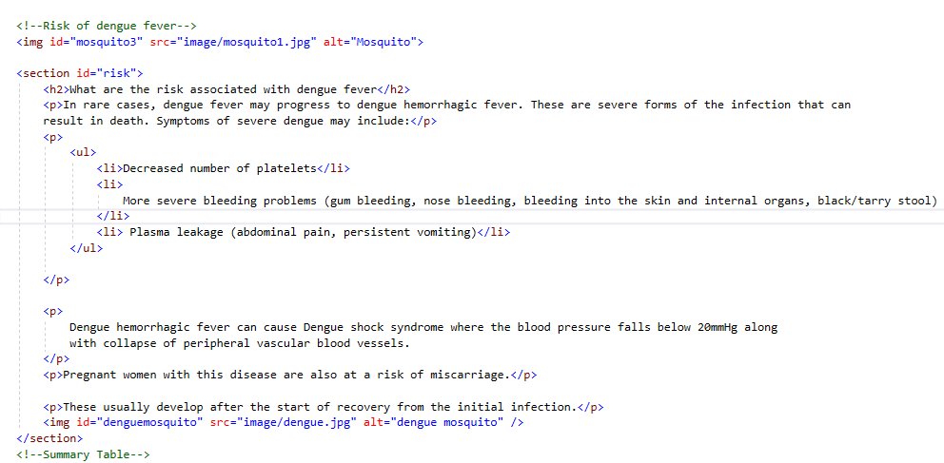

To maintain the same feel with the rest of the page, the color used are of the same color scheme. The content follows the logical sequence of allowing one to fully understand this section, starting with introduction of the disease named Dengue Fever which gives a brief description of how dengue mosquito could result in dengue fever, followed by the symptoms of it that could be observe for early detection of dengue fever and to seek treatment early. The risk that could be associated because of the effect from dengue fever could be fatal. All these information included will better educate the viewer about dengue fever.

**4. Summary Table**

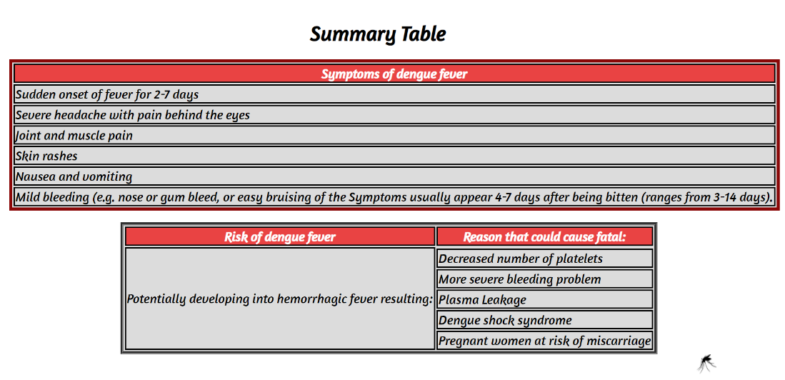

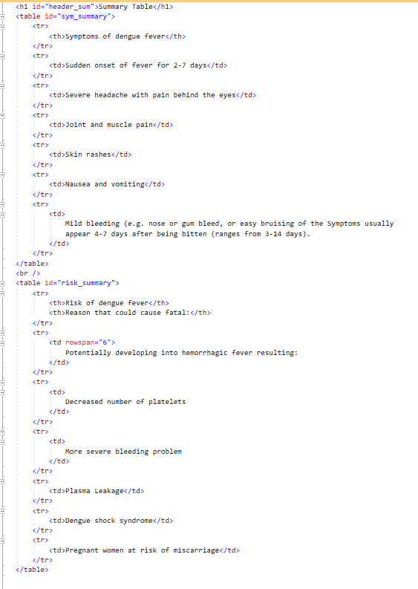

Followed by the summary table that summarizes what was said in the webpage to better consolidate what was learnt.

**5. For more information**

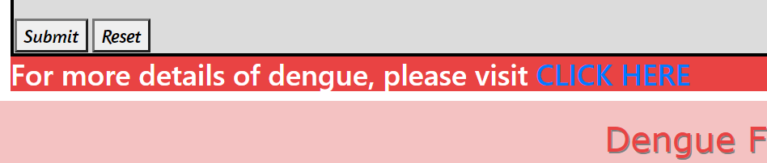

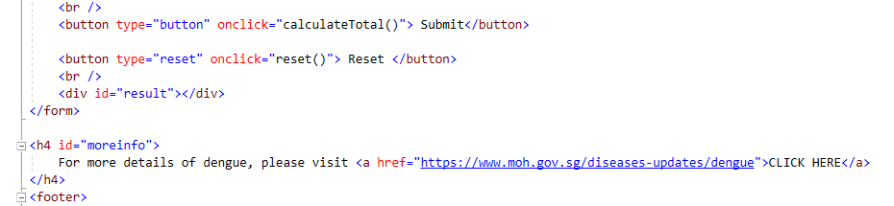

Then end off with a hyperlink for those who are interested to know more about dengue. This link is connected to the Ministry of Health which is an official website that provides more accurate and updated information of dengue.

## Header/Footer Inclusion

**Header**

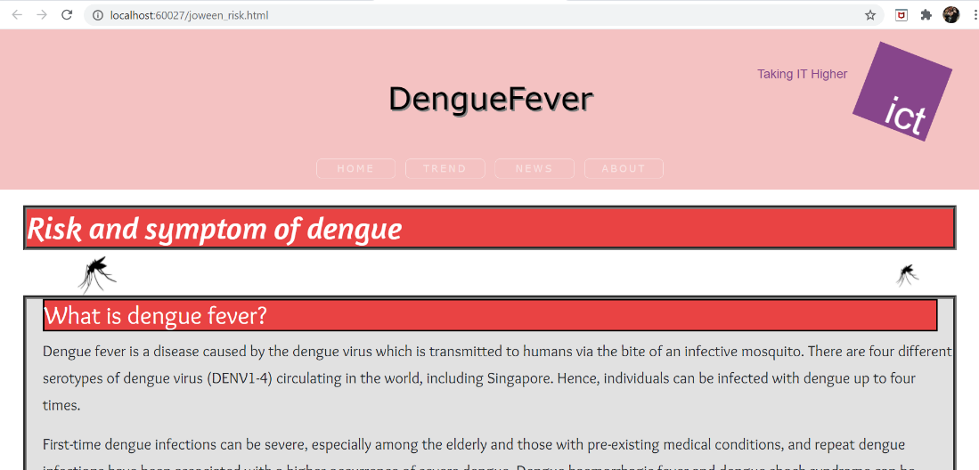

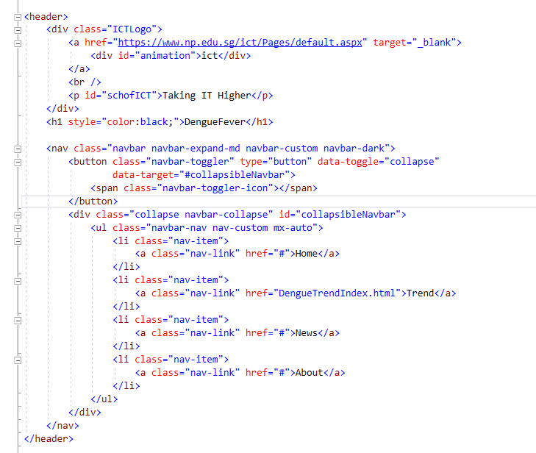

**Footer**

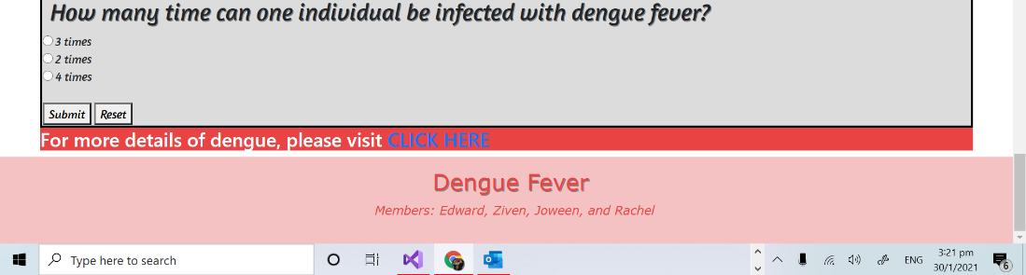

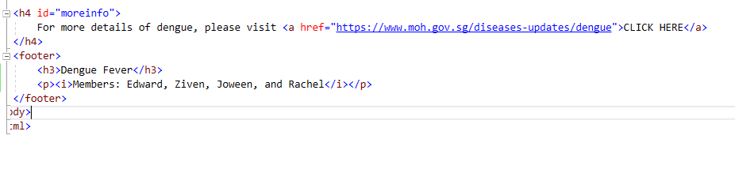

Th header and footer code are added to achieve consistency between each page as user navigate using the navigation bar. The header consists of animated box that can rotate automatically in 360 degrees direction and upon clicking on it, it will link to the ICT websites. The footer consists of our team and team member's name.

## Responsive Element

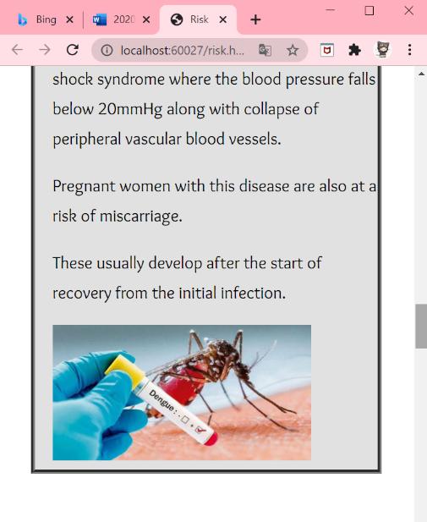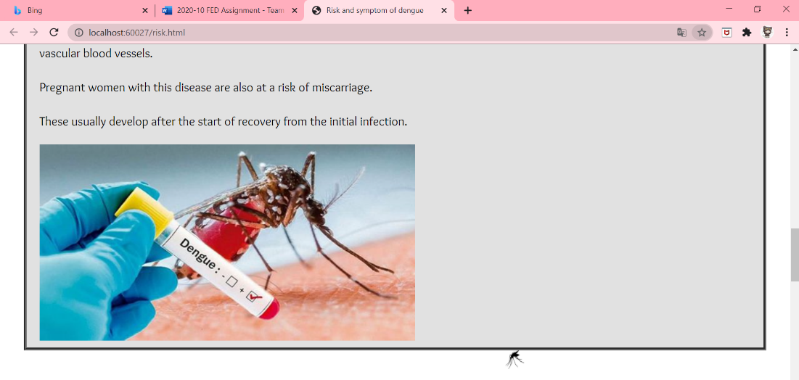

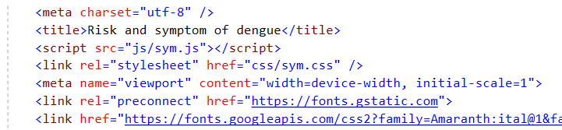

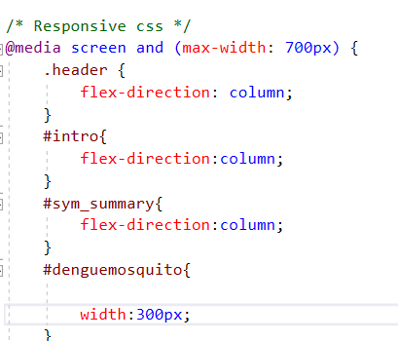

Image will resize when on smaller screens, Eg. The dengue mosquito image will resize to 300px width. The summary table will also respond and resize as column table.

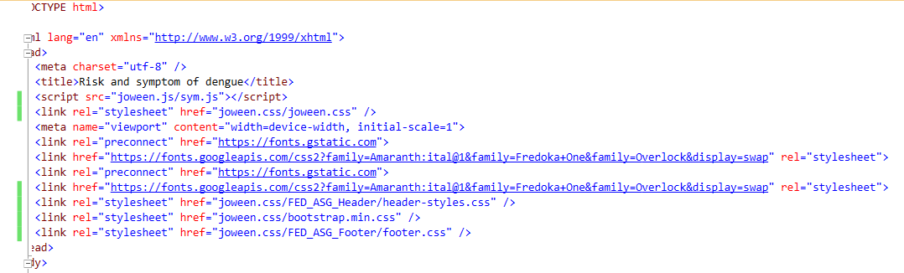

Bootstrap is used for the header to provide the animation features.

## Javascript/JQuery Implementation

1st part: 2nd part:

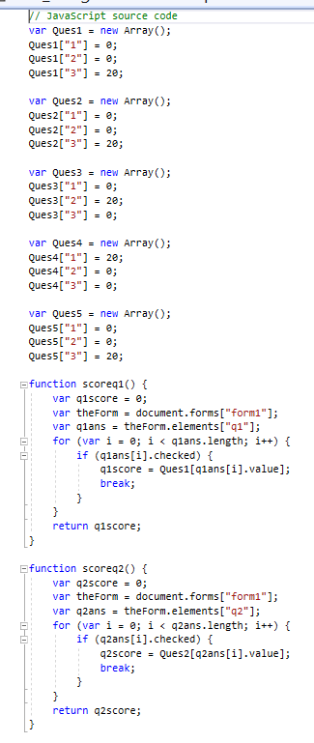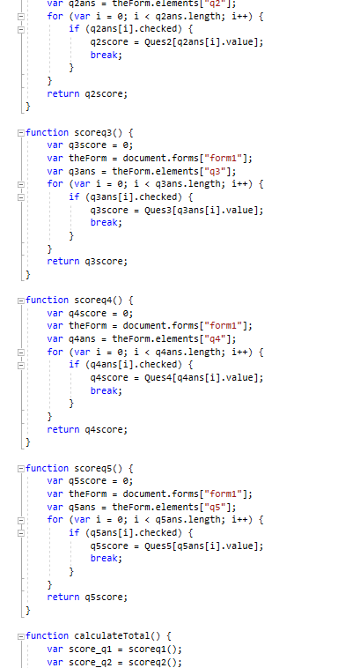

3rd part:

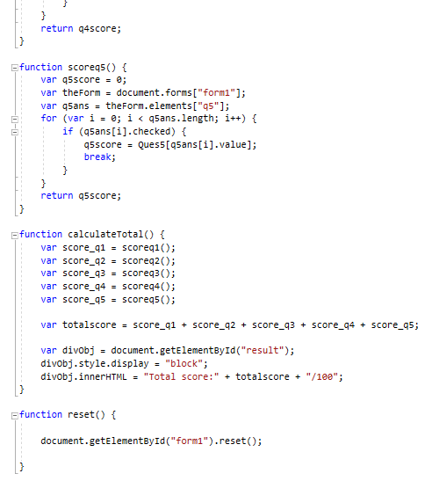

Uses JavaScript to calculate and return the score for the quiz implemented to test the user knowledge based on this section (Risk and symptoms) after reading through it.

## External Stylesheet

Parts of css code: Main paragraph

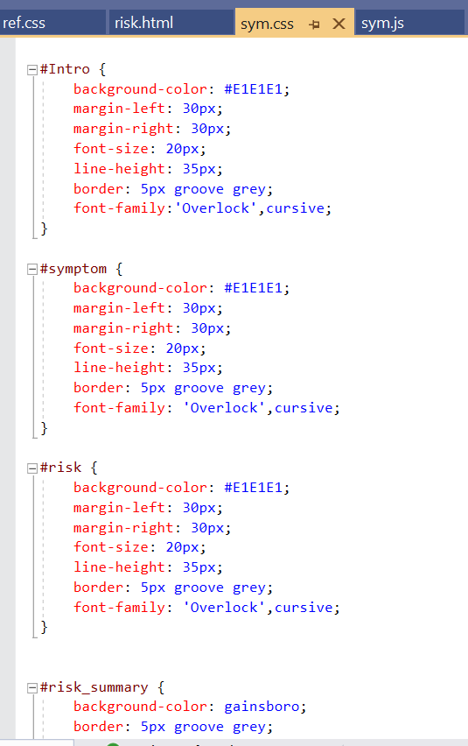



These are some examples of css code that was used to style the webpage content to be more visually appealing by using background color such as #E1E1E1 and to include alignment such as margin. It is also used to control the animation of mosquito hover over that I used ,which uses keyframe.

## Animation & Multimedia

Pictures: Animation:

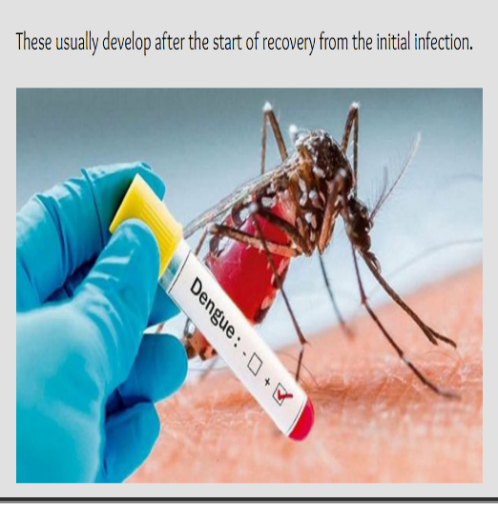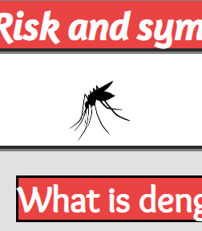

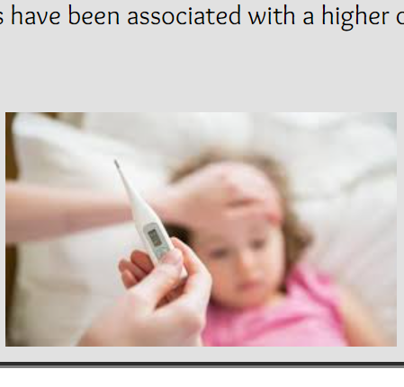

Animation code:

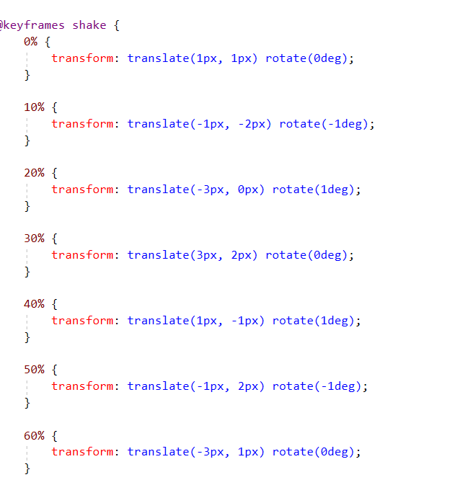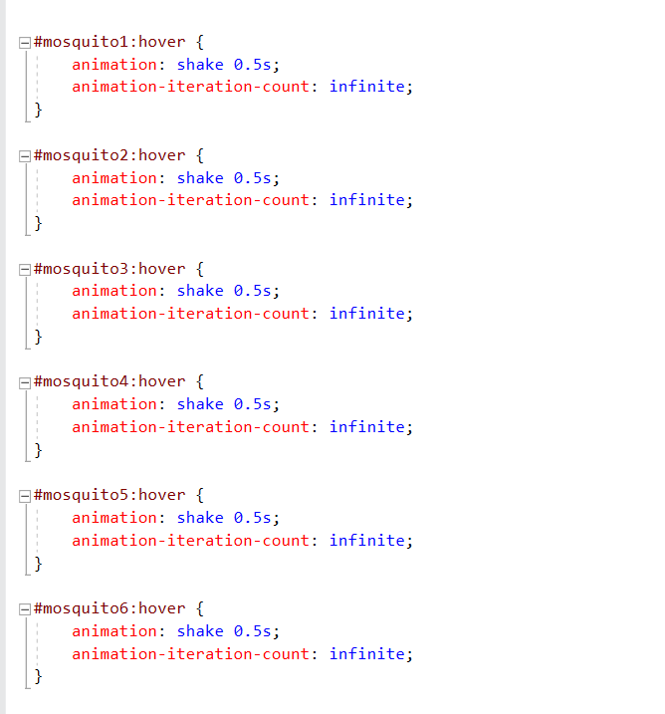

Animation is implemented, when user was to mouse hover the mosquito picture, the picture will shake and move in different degree at different percentage of motion. The header also uses animation to rotate in 360 degrees at infinite.

Image code:

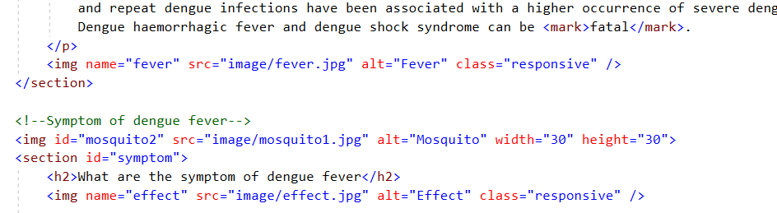

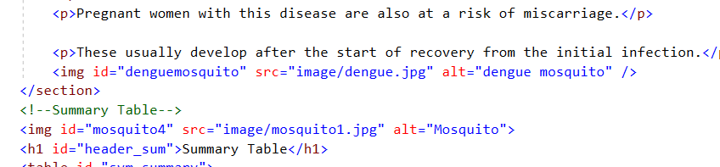

## Form Implementation

Quiz:

It is implemented to test the knowledge of viewer after reading all the info in this section. It makes use of JavaScript to submit, reset and calculate the score obtain upon submitting.

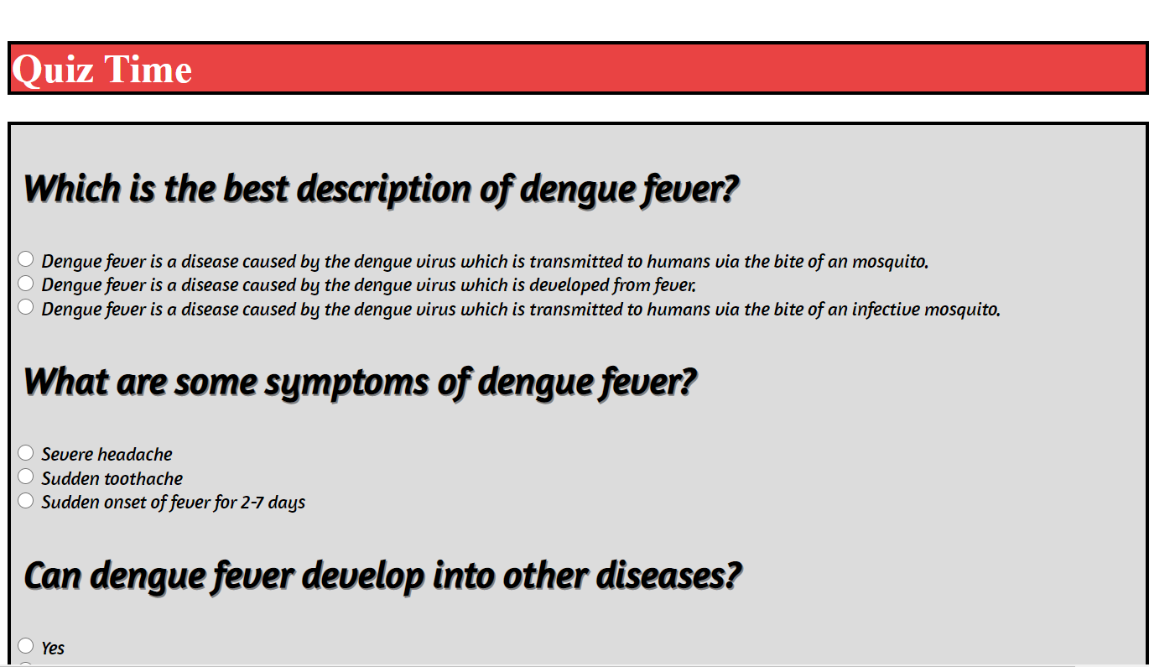

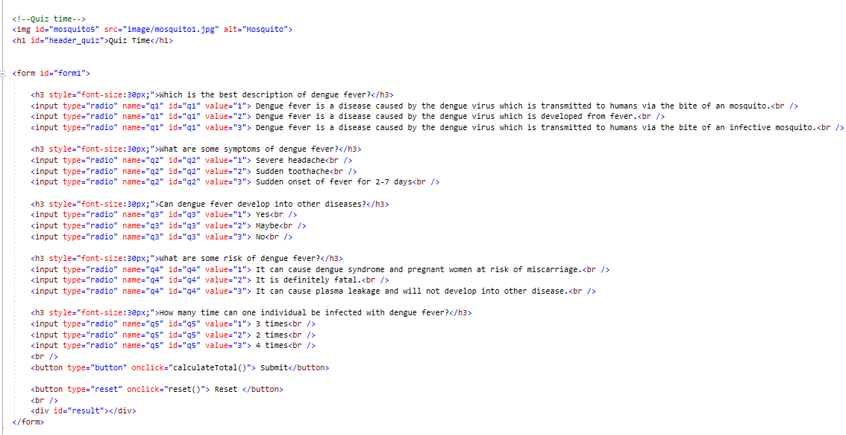

# Member 4 (Rachel)

## Webpage Content

Contents in my transmission webpage are split into 5 sections, about dengue, how dengue is transmitted, about aedes mosquito, a section for form, and links.

About Dengue

At the top of the page, I first start of my content by including a brief description on what is dengue and a few statistic information to support my writings. Refer to Figure 4.1.1 to get the full content of my ‘About Dengue’ section.

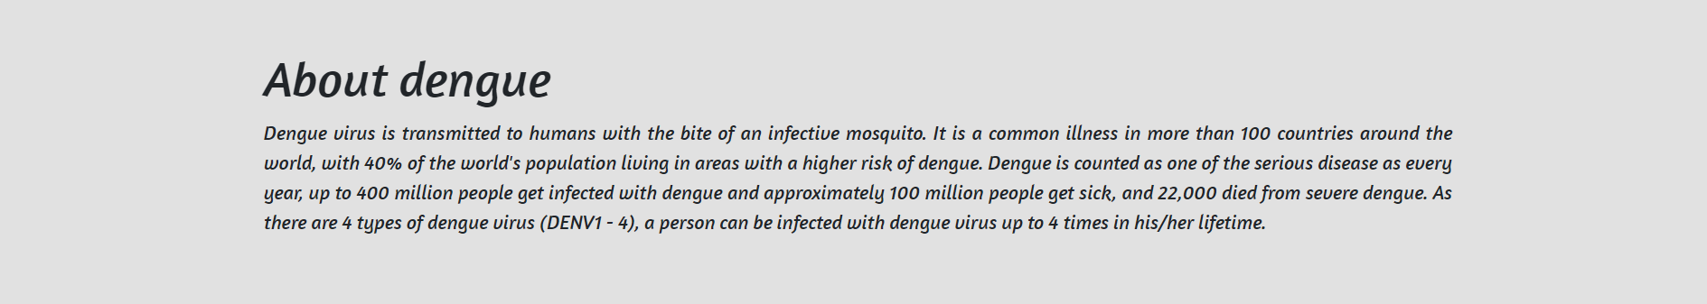

Figure 4.1.1 About Dengue

How Dengue Is Transmitted

Next, I moved on to explain the few ways of dengue transmission. I arranged the content in an unordered list and inserted 2 images for the reader to get a piece of clear and precise information at their first glance. Refer to Figure 4.1.2 to get the full content of my ‘How Dengue Is Transmitted’ section.

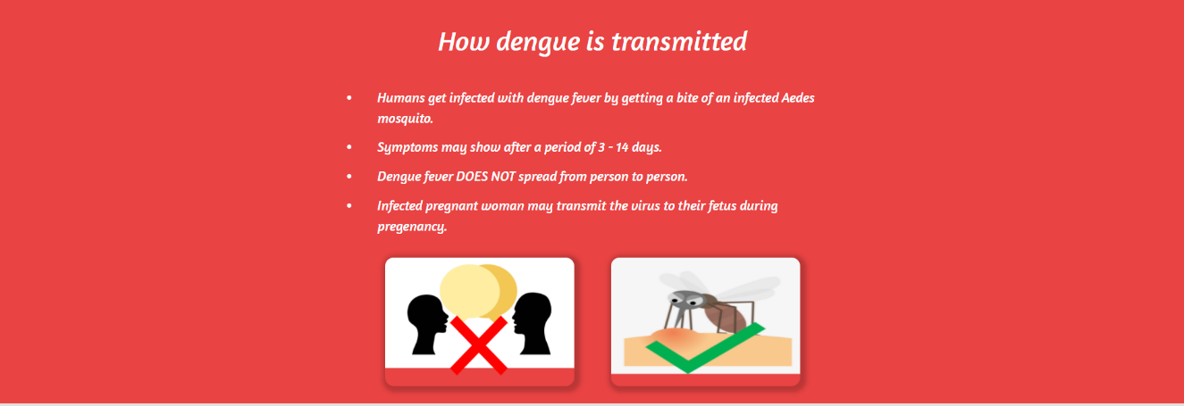

Figure 4.1.2 How dengue is transmitted

About Aedes Mosquito

Next, for this section, I have split it into 2 parts.

For the first part, I went researched deeper into the details of the dengue mosquito, Aedes. I described the features of aedes and how did it get infected. To support the contents, I included an image of an Aedes mosquito to give the reader a clear appearance of it. The arrangement of content is similar to my ‘How dengue is transmitted’ content. Refer to Figure 4.1.3 to get the first part of the content on the ‘About Aedes Mosquito’ section.

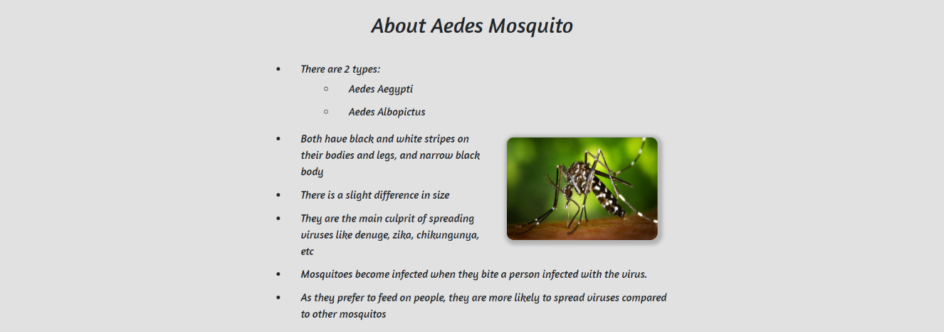

Figure 4.1.3 About Aedes Mosquito 1

For the second part, I created a table to list down the differences between Aedes Mosquitos and other common mosquitos. Refer to Figure 4.1.4 to get the second part of the content on the ‘About Aedes Mosquito’ section.

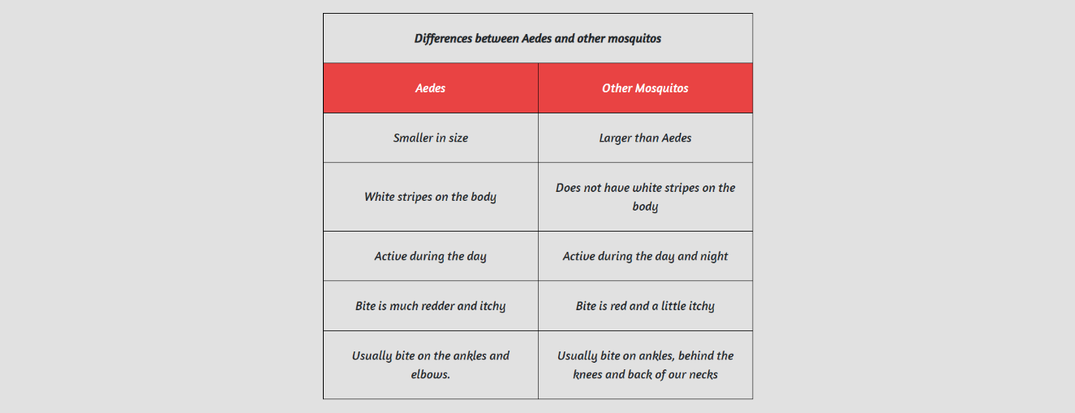

Figure 4.1.4 About Aedes Mosquito 2

‘Are You Able to Differentiate’ Form

Next, I have created a form for reader to challenge themselves to differentiate the mosquitos by the features I have covered in the above sections. Refer to Figure 4.1.5 to get the content of my ‘Are You Able to Differentiate’ form.

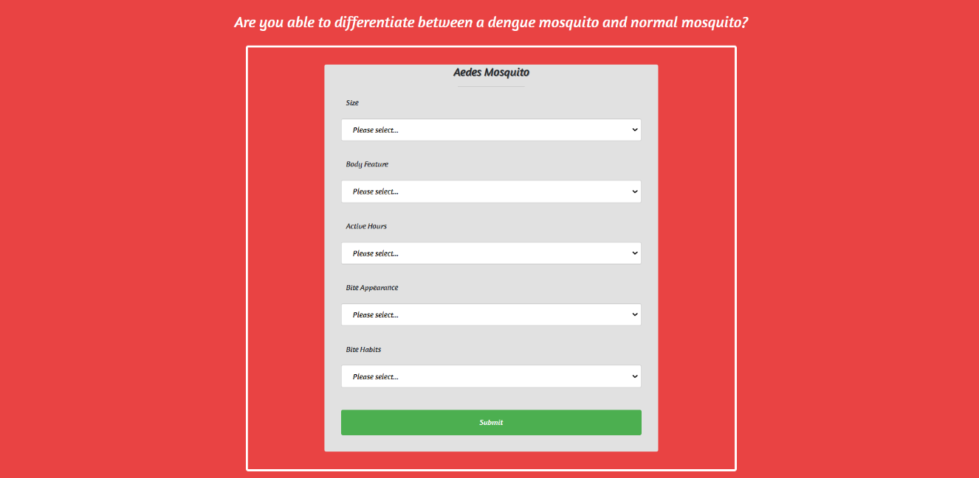

Figure 4.1.5 ‘Are You Able to Differentiate’ Form

Links to find out more about Dengue and the mosquito

Lastly, I have included a section for useful links, for the reader who are eager to know more about the contents I have covered above. Refer to Figure 4.1.6 to get an idea of how my ‘Links’ sections look like.



Figure 4.1.6 Links to find out more about Dengue and the mosquito

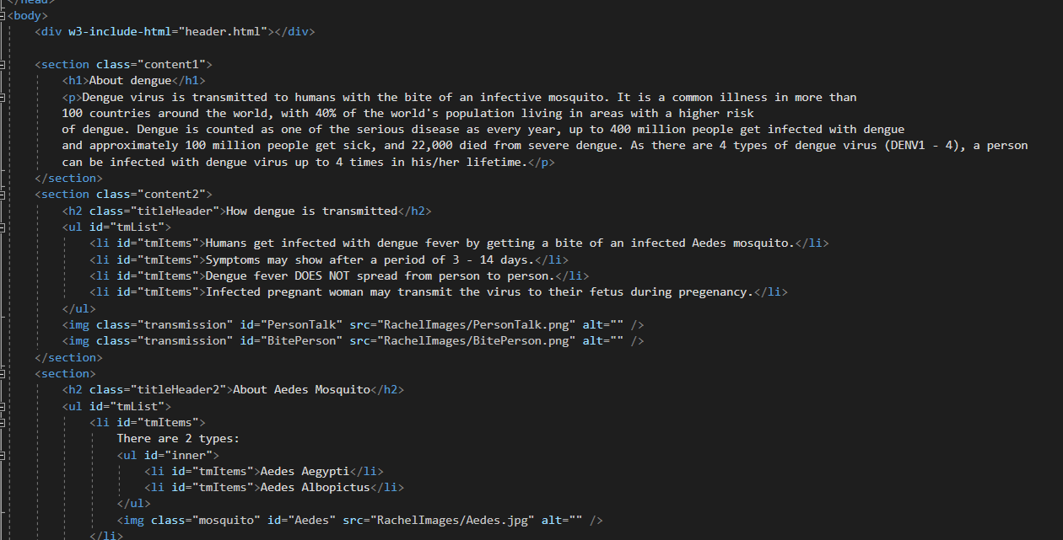

Figure 4.1.7 Codes for the 1 part of the above content

## Header/Footer Inclusion

As for the header and footer, I have included the ones that my team and I created for the home page, to standardise the layout of our webpages.

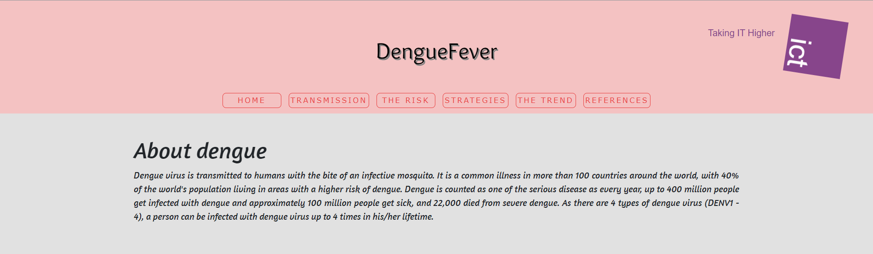

Figure 4.2.1 Header for Transmission Page



Figure 4.2.2 Footer for Transmission Page

## Responsive Element

For responsive element, instead of adding bootstrap container-fluid or image-fluid, I used the basic way to make it responsive by adding the code highlighted in Figure 4.3.1. Refer to Figure 4.3.2, Figure 4.3.3, and Figure 4.3.4 to see how did the page response to the different width-size of the browser.

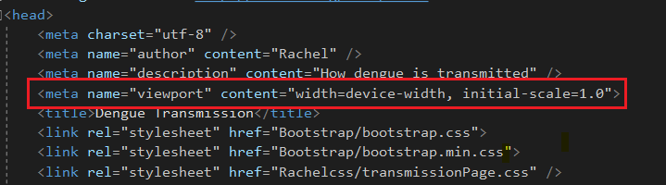

Figure 4.3.1 HTML code for responsive element

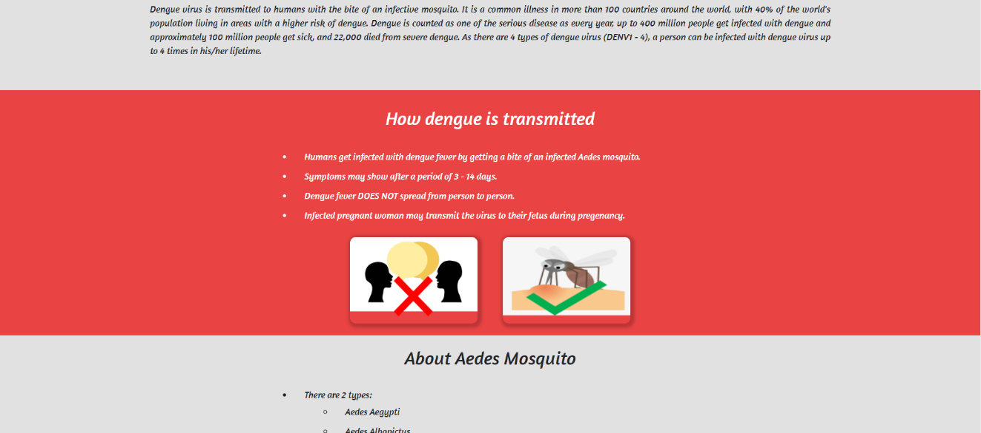

Figure 4.3.2 Transmission webpage at 100% width

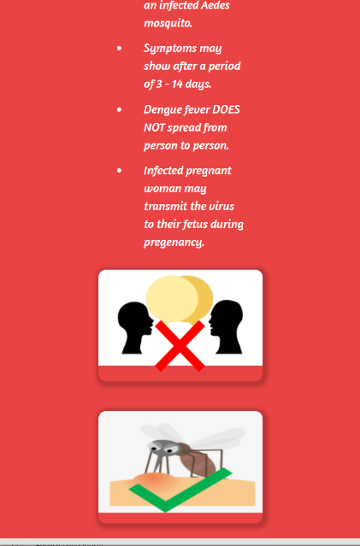 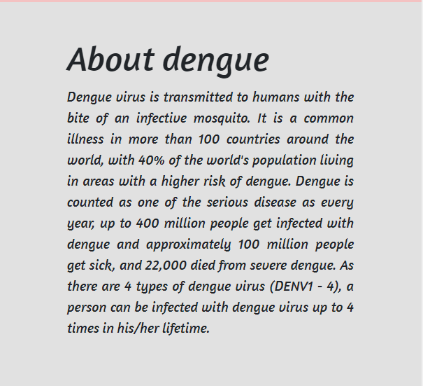

Figure 4.3.3 Figure 4.3.4

Transmission webpage at 30% width Transmission webpage at 30% width

## Javascript/JQuery Implementation

For Javascript, I used window.onscroll to get the webpage’s height and then based on the height, it will display images. Refer to Figure 4.4.1 for the codes. Refer to Figure 4.4.2 and Figure 4.4.3 to see the displaying of image based on the height from the top of the webpage.

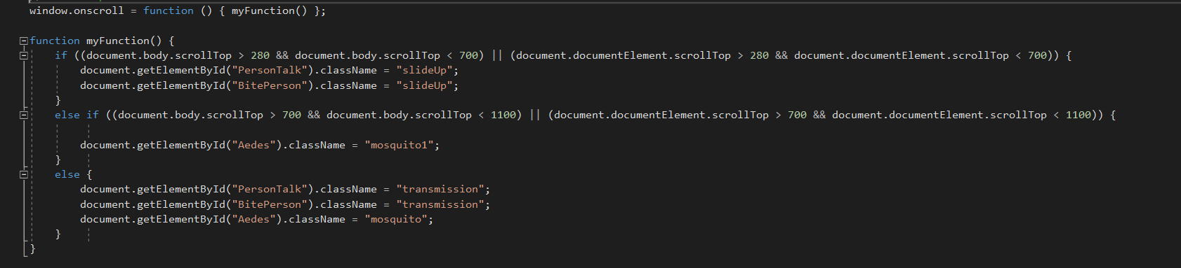

Figure 4.4.1 Codes for Javascript Displaying of Image

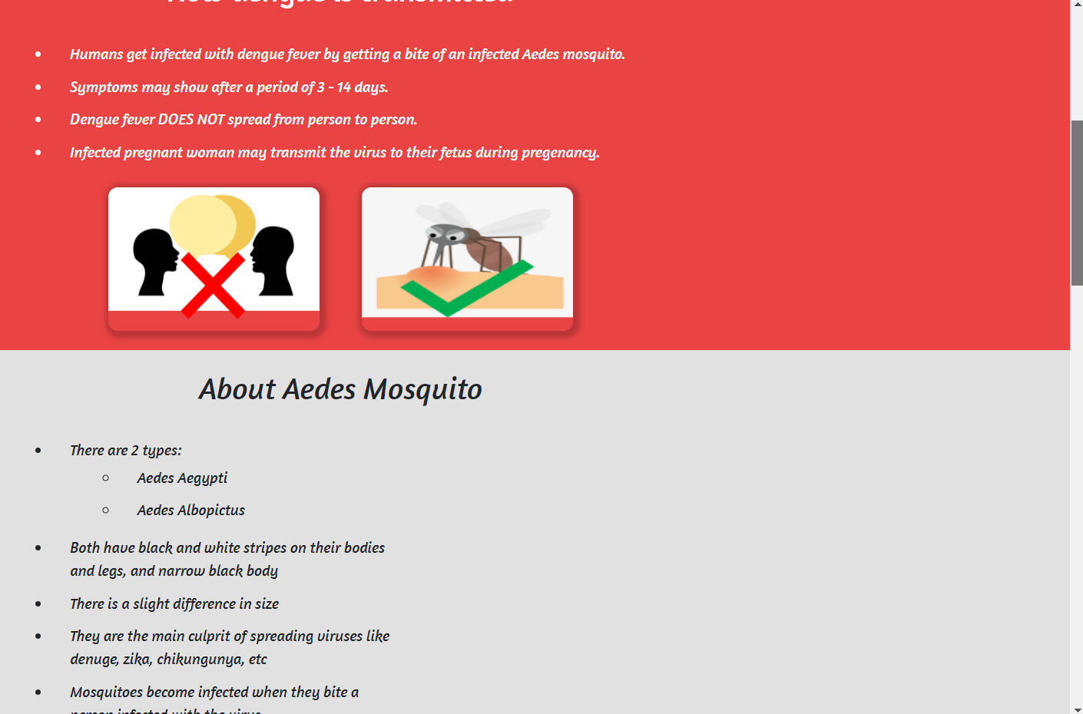

Figure 4.4.2 At 1/4 height of the webpage

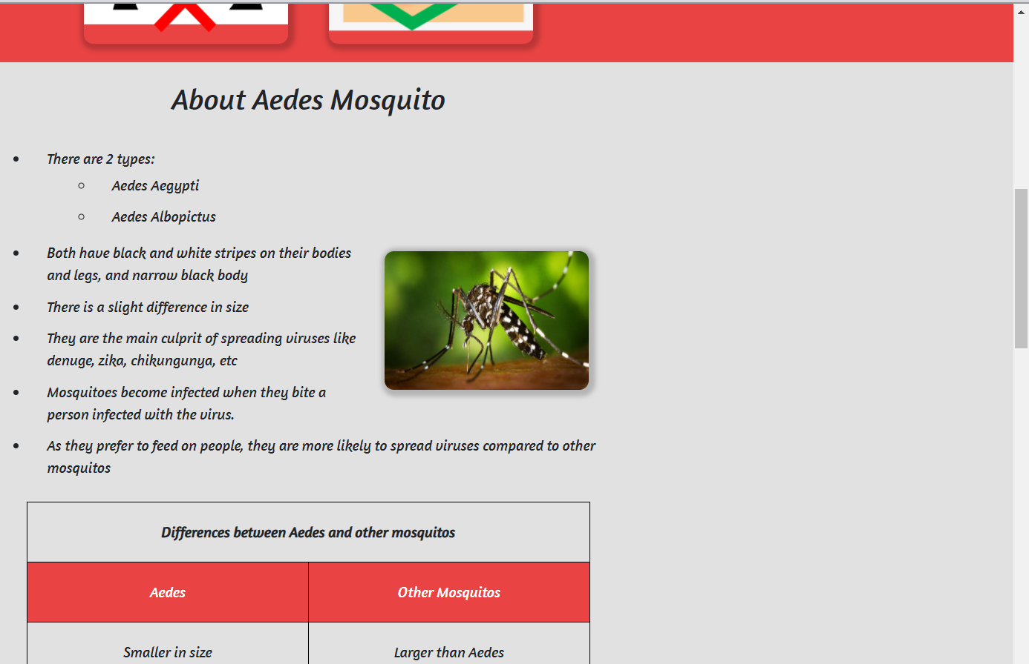

Figure 4.4.3 At 1/2 height of the webpage

## External Stylesheet

The base of my styling is based on the code in Figure 4.5.1, with the background colour: #E1E1E1 and centre alignment.

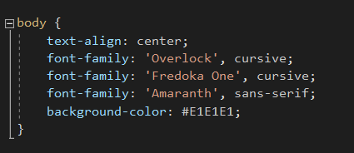

Figure 4.5.1 Styling Codes for overall webpage

Styling codes for section: About Dengue

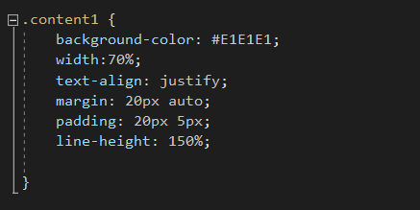

Figure 4.5.2 Styling codes for ‘About Dengue’

Styling codes for section: How Dengue is Transmitted

tmLlist and tmItems are codes for the unordered list, tableHeader is for the title ‘How is Dengue Transmitted’, and content2 is the wrap around for this section.

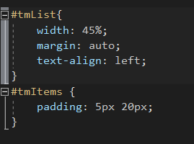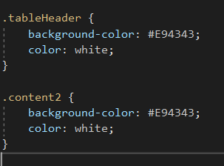

Figure 4.5.3 Styling codes for ‘How Dengue is Transmitted’

Styling codes for section: About Aedes Mosquito

Similar to ‘How dengue is transmitted’ section, tmList and tmItems are for the lists, inner is the nested list, and titleHeader2 connects to the title ‘About Aedes Mosquito’. Table, th, td the code for styling of table

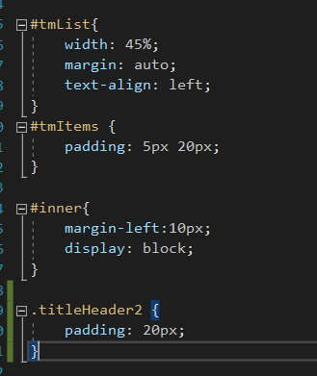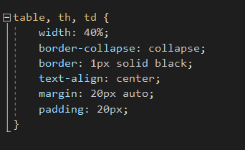

Figure 4.5.4 Styling codes for ‘About Aedes Mosquito’

Styling codes for section : ‘Are You Able to Differentiate’ Form

wrapForm is the codes for the form and quizWrapper styles the base of this section, #E94343 colour.

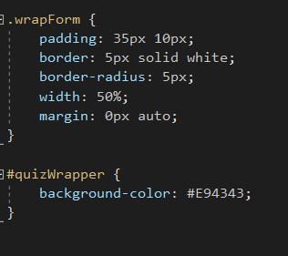

Figure 4.5.5 Styling codes for ‘Are You Able to Differentiate’ Form

Styling codes for section : Links to find out more about Dengue and the mosquito

For this last section, I used bootstrap class, btn btn-outline-info btn-block to style my buttons and content5 to style the padding of the section

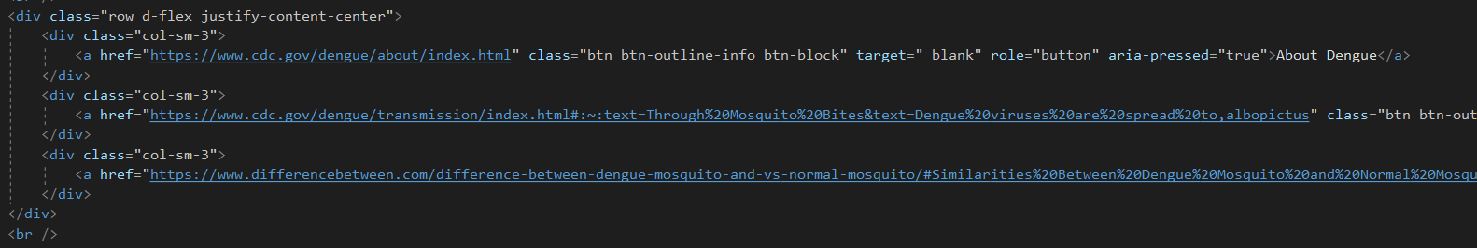

Figure 4.5.6 Styling codes for buttons

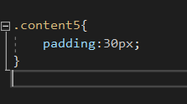

Figure 4.5.7 Styling codes for Links to find out more about Dengue and the mosquito

## Animation & Multimedia

I have animated the appearing of images to slide in according to the javascript code I have covered above (window.scroll of height from top of webpage). Refer to Figure 4.6.1 and 4.6.2 for the codes for the animation of the images and refer to Figure 4.6.3 to see the image fading in.

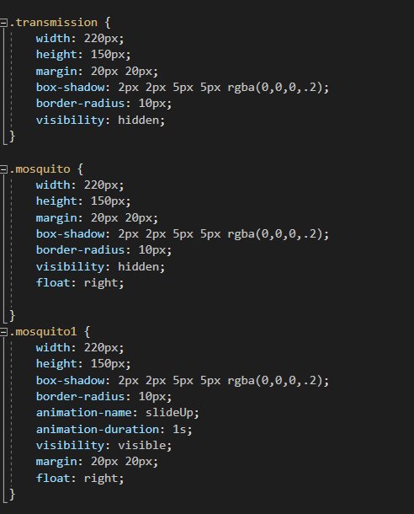

Figure 4.6.1 Codes for animation of image

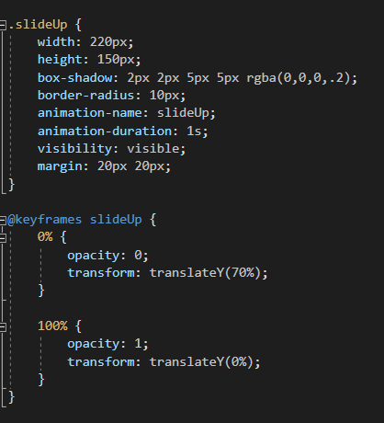

Figure 4.6.2 Codes for animation of image

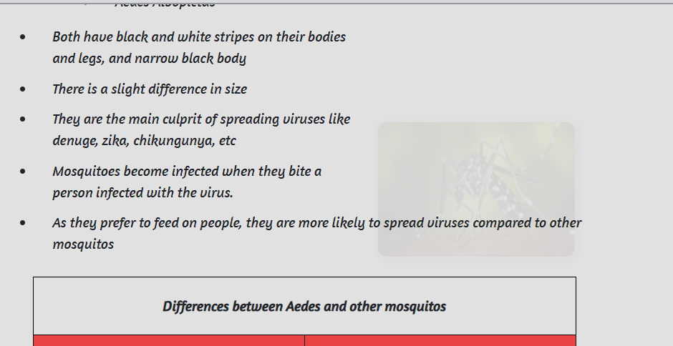

Figure 4.6.3 Image Fading In

## Form Implementation

I have implemented a simple form for readers to have a quick challenge for themselves to recognise the different features of Aedes mosquito. With 5 selection and 2 options each for readers to select. If a selection has left out and not yet selected an option, user will not be able to submit the form. Upon submission, a javascript function will be activated and list down the corrects and wrongs of the selected options. Refer to Figure 4.7.1 for the options, Figure 4.7.2 for the error upon submission, and Figure 4.7.3 for the display of results upon submission.

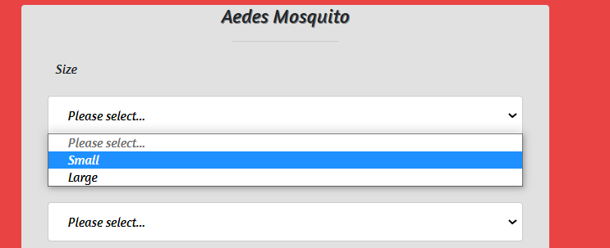

Figure 4.7.1 Select Options

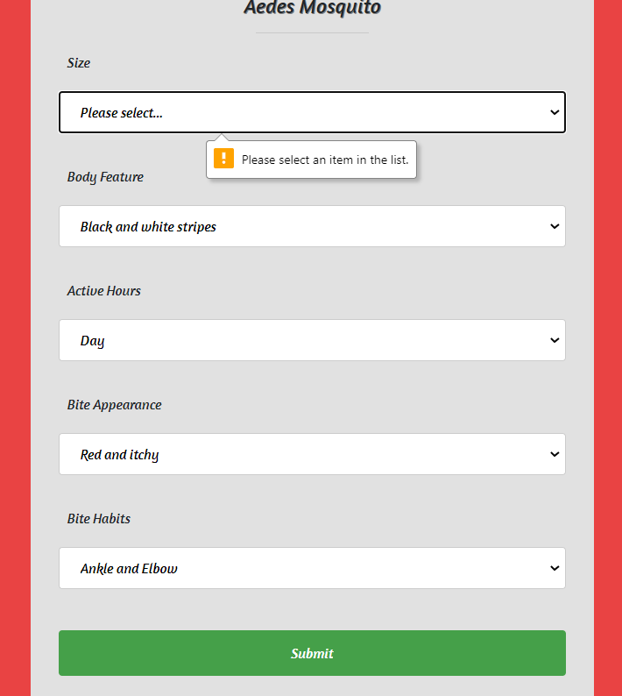

Figure 4.7.2 Error for not selecting an option

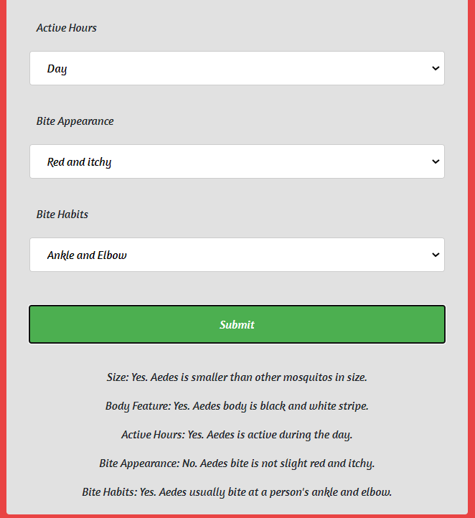

Figure 4.7.3 Upon Submission